Knowledgebase for Key Event 1

1 Key Executives Dynamics 1

1.1 Appointment and Role Transition 1

1.2 Retirement/Termination of Key Executives 1

1.3 Key Executive Stock Awards 1

2 Sustainability Bulletin 1

2.2 Environmental Conservation Programs 1

2.3 ESG Reporting and Compliance 1

2.4 Recognition for Sustainability 1

3 Capital Transactions 1

3.1 Issuance of shares 1

3.2 Issuance of Debt 1

3.3 Credit Agreements 1

3.4 Redemption of Debt 1

3.5 Redemption of Shares 1

4 Equity Stake Deals 1

4.1 Stake acquisition 1

4.2 Stake Sell-off 1

5 Earnings Communications 1

5.1 Announcement of Earnings 1

5.2 Periodical Financial Reports 1

6. Corporate Actions 1

6.1 Conversion of shares 1

6.2 Conversion of Debt 1

6.3 Repurchase of shares 1

6.4 Repurchase of Debt 1

6.5 Dividend Communications 1

6.6 Exchange of Notes 1

6.7 Merger and Acquisitions 1

6.8 Divestiture of 1

diary/Division 1

6.9 Securities Listing Event 1

6.10 Stock Split 1

6.11 Reverse stock split 1

6.12 Spin-off 1

6.13 Right Issue 1

6.14 Ticker Symbol Update 1

7 Strategic Collaborations Bulletin 1

8 Significant Assets Transactions 1

8.1 Strategic Capital Investments 1

8.2 Disposition of Assets 1

9 Legal and Regulatory Updates 1

10 Product/Service Releases and Updates 1

11 Investor Engagement 1

11.1 Earnings Conference 1

11.2 Conferences & Summits 1

11.3 Annual General Meeting 1

11.4 Extra-ordinary General Meeting 1

11.5 Fireside chats 1

11.6 Analyst/Investor Day 1

11.7 Roadshow 1

12 Operational Updates 1

12.1 Suspension of business/Facility 1

12.2 New Commercial Facility 1

12.3 Critical incident updates 1

12.4 Management Guidance 1

12.5 Workforce Transition Updates 1

12.6 Financial Segment Restructuring 1

12.7 Sales and Production Figures 1

12.8 Orders and contracts 1

12.9 Regulatory Approvals and Compliance 1

12.10 1

Updates 1

12.11 Business updates 1

13 Legal Investigations & Lawsuits 1

14 Others 1

Contents

# Knowledgebase for Key Event

1. **News Mapping:**
2. If the news has all the data with complete content, then only we will tag it with the subcategory.
3. If we receive complete news from any source & its title is wrong or incomplete (For e.g. the title will be having just some special character or any number which is not relevant to the news), then we need to update the **Title** available in the news & confirm the news accordingly. (Most of the incomplete or incorrect title are fetched through Press release source.)

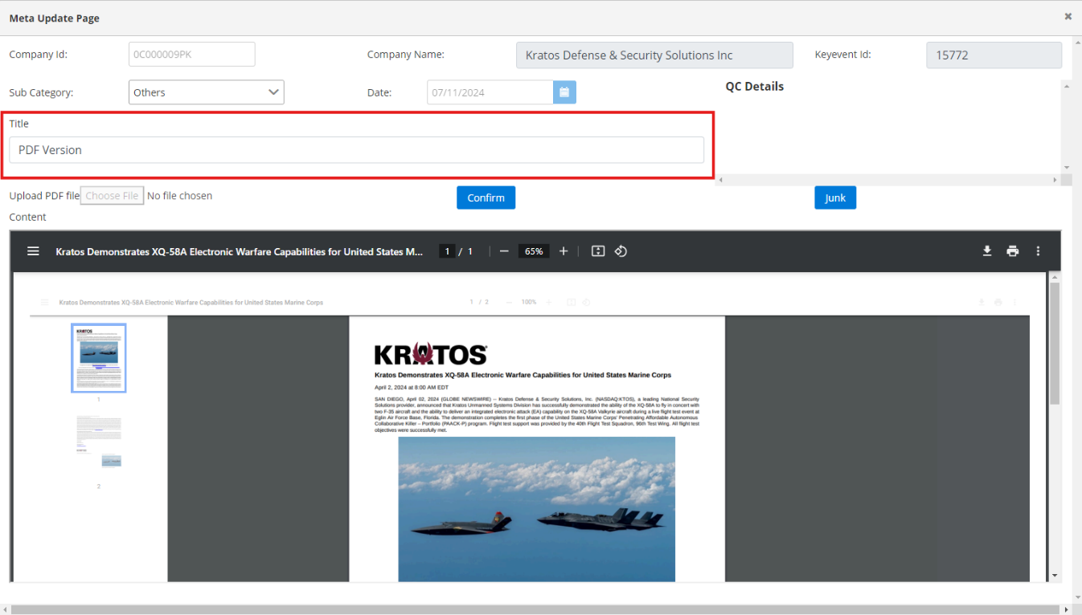In the below screenshot you can see that the title is wrongly fetched as PDF Version & in the second screenshot you can see the updated title from the news.

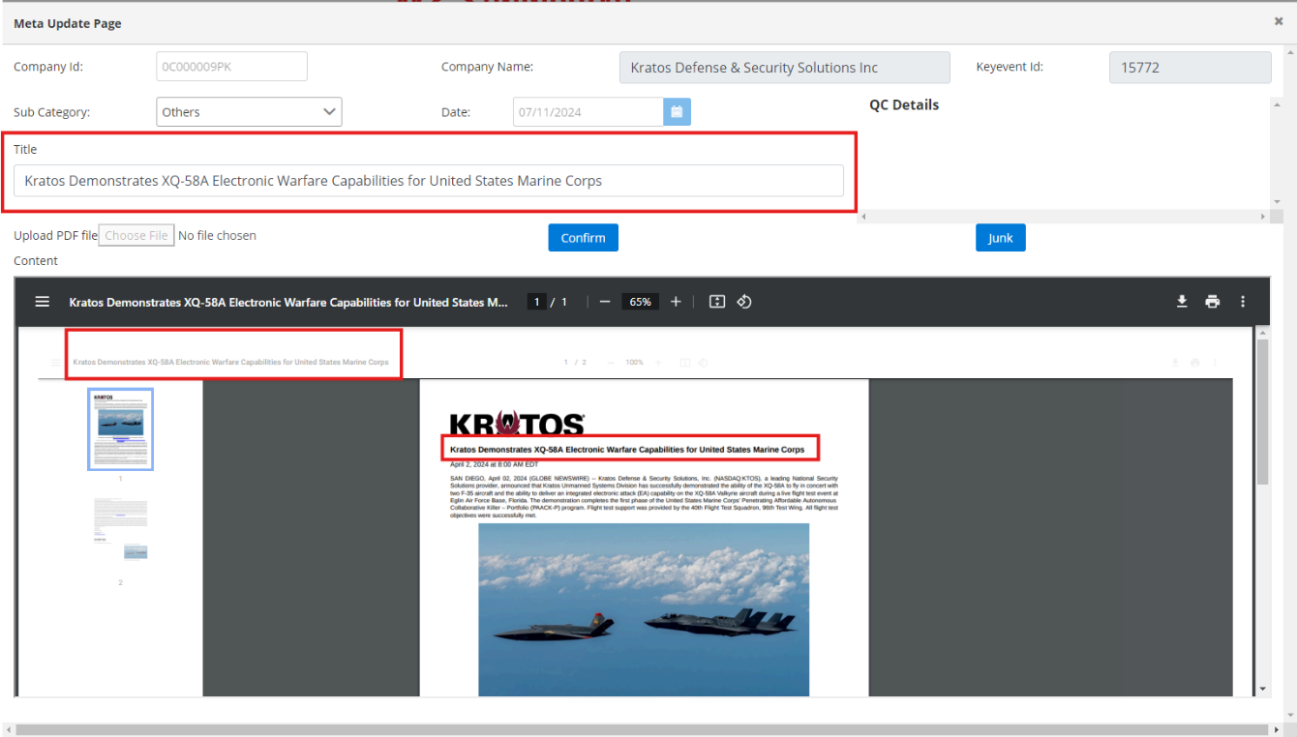

1. **News Junking:**
2. Native language news will be junked.
3. Incomplete news comes in Key events will be junked.
4. If we receive news through SEC source with sub-category then we need to check the duplicate news & compare, if the news is already auto-confirmed is having complete content then we will junk the news which is fetched from the SEC source. If the Auto-confirmed news is incomplete & the duplicate news from SEC source is complete, then we need to confirm SEC news & junk the Auto-confirmed news.
5. News containing below keywords in Title should be junked.
6. Director/PDMR Shareholding
7. Net Asset Value or NAV
8. Form 8.3
9. Form 8.5
10. Total Voting Rights
11. Notification of Major Holdings

**Key events categories Methodology**

**Introduction-**

This methodology documents outline how the key events categories will be assign to respective key news**.**

**Event categories-**

**Main Category:**

main categories.

**Subcategory:**

A subcategory is a more specific classification or subdivision within a broader main category. It provides further granularity and detail by categorizing related news. We have total 54 subcategories.

# Key Executives Dynamics

Key Executives Dynamics" refers to the events and changes related to top-level executives like (CFO, Director, officer, CEO, CTO and other key executive define by the company) within a company. This includes appointments, role transitions, retirements, terminations, and stock awards granted to key executives.

Below are the sub-categories of Key executive dynamics-

1. Appointment and Role Transition-
2. Retirement/Termination of Key Executives
3. Key Executive Stock Awards

Below are the examples of sub-categories within the Main category of Key executive dynamics-

**Subcategory 1**

## 1.1 Appointment and Role Transition

Definition-

This subcategory involves the announcement of key executive appointments and any shifts in their roles. It provides stakeholders with insights into leadership changes and the strategic direction of the organization.

Example-1

CID- 0C000007HW

Name- Equinix Inc

Link-

[Equinix Appoints Adam Berlew as Chief Marketing Officer :: Equinix, Inc. (EQIX)](https://investor.equinix.com/news-events/press-releases/detail/1013/equinix-appoints-adam-berlew-as-chief-marketing-officer)

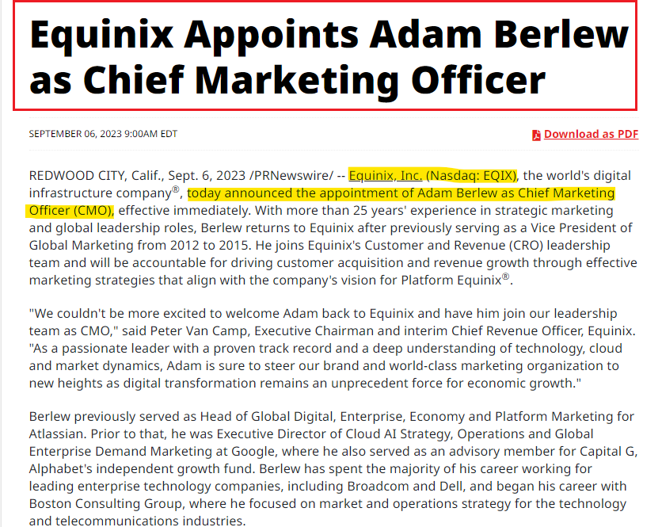

Comments-

Based on the highlighted part from the snippet above, where the company mentions the appointment of Adam Berlew as chief executive officer, we should categorize this event as 'Appointment and Role Transition’.

Example-2

CID- 0C00000BO5

Company Name- Johnson & Johnson

Link-<https://www.sec.gov/ixviewer/ix.html?doc=/Archives/edgar/data/0000200406/000020040623000115/jnj-20231130.htm>

Snip-

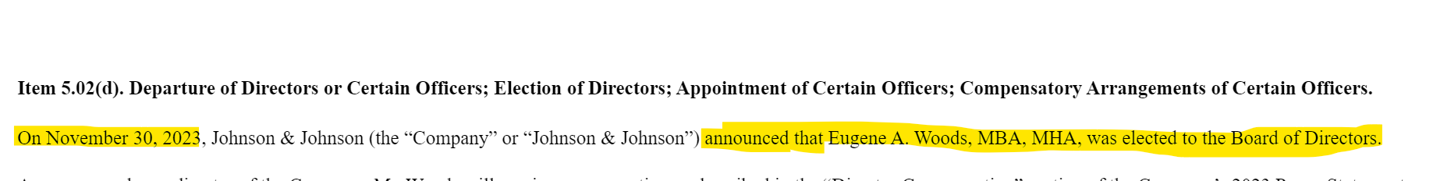

Comments-

As highlighted in the snippet above, we can categorize these events as ‘Appointment and Role Transition.’

since the company is announcing that Eugene A. Woods was elected as BOD.

**Subcategory 2**

## 1.2 Retirement/Termination of Key Executives

Definition-

Retirement/Termination of Key Executives: Details regarding the retirement or termination of key executives, and events announcing key executives opting out of re-election.

Example-1

CID- 0C0000C33R

Company Name- TuSimple Holding

Link- [LINK](https://ir.tusimple.com/press-releases/news-details/2022/TuSimple-Announces-Termination-of-Chief-Executive-Officer-and-the-Initiation-of-a-Search-for-a-New-Chief-Executive-Officer-10-31-2022/default.aspx)

Snip-

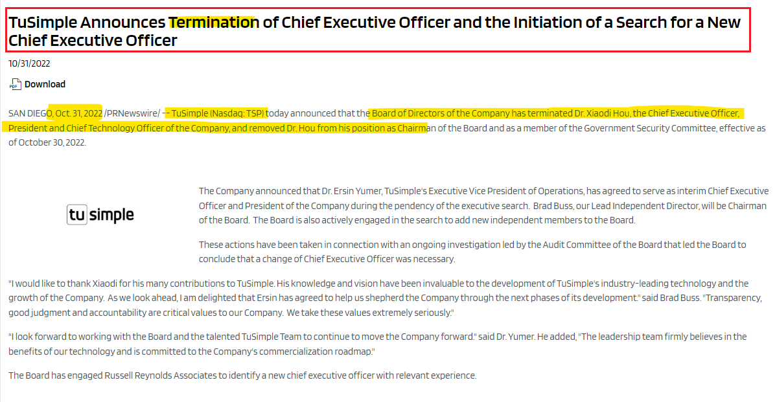

Comments-

As stated in the snippet above, we can categorize these events as Retirement/Termination of Key Executives since the company is announcing the termination of the CEO.

Example-2

CID- 0C00000YHP

Company Name- Novo Integrated Sciences, Inc

Link- <https://dcpdprodweb6001.morningstar.com/execcomp/dataFiles/0001493152-24-006975.htm>

Snip

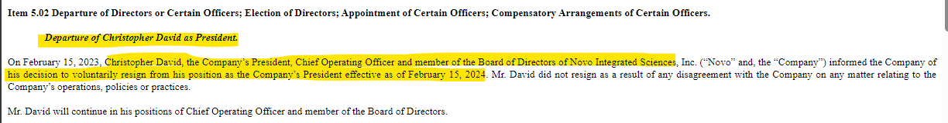

Comments-

As stated in the snippet above, we can categorize these events as Retirement/Termination of Key Executives since the company is announcing the departure of David as president.

**Subcategory 3**

## 1.3 Key Executive Stock Awards

Definition-

Key Executive Stock Awards" involve the significant granting of company stock or stock options to key executives as part of their compensation. The stock awards granted to general employees are not covered under this category.

Example-1

CID- 0C0000187F

Company Name- Giyani Metals Corp

Link- [Giyani Announces Grant of Stock Options and RSUs (globenewswire.com)](https://www.globenewswire.com/news-release/2024/02/20/2831836/0/en/Giyani-Announces-Grant-of-Stock-Options-and-RSUs.html)

Snip

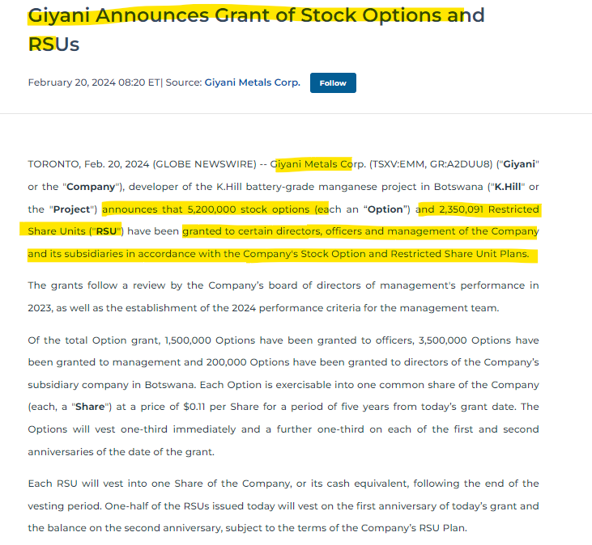

Comments-

As stated in the snippet above, we can categorize these events as ‘Key Executive Stock Awards’

since the company is announcing stock options and RSUs.

Example-2

CID- 0C00000AMP

Company Name- Comcast Corporation

Link- [Inline XBRL Viewer (sec.gov)](https://www.sec.gov/ixviewer/ix.html?doc=/Archives/edgar/data/0001166691/000095010322021872/dp186161_8k.htm)

Snip



Comments-

As stated in the snippet above, we can categorize these events as ‘Key Executive Stock Awards’

since the company is announcing performance Awards to Mr. Cavanagh.

# Sustainability Bulletin

Sustainability Bulletin serves as a central repository of information that communicates the company's sustainability efforts, achievements, and aspirations, reinforcing its dedication to environmental stewardship, social responsibility, and ESG reporting and compliance.

Below are the sub-categories of Sustainability bulletin-

1. Social Responsibility Initiatives
2. Environmental Conservation Programs
3. ESG Reporting and Compliance
4. Recognition for Sustainability

Examples of sub-categories within the Main category of Sustainability Bulletin

**Subcategory 1**

2.1 Social Responsibility Initiatives

Definition-

This section focuses on the company's efforts in social responsibility, detailing initiatives that address societal challenges, promote community welfare, and demonstrate corporate citizenship. This includes partnerships with NGOs, community development projects, and philanthropic endeavors that contribute to the company's positive societal impact.

Example-1

CID- 0C00000AMP

Company Name- Comcast Corporation

Link- <https://corporate.comcast.com/press/releases/comcast-nbcuniversal-unrestricted-grants-81-nonprofits>

Snip

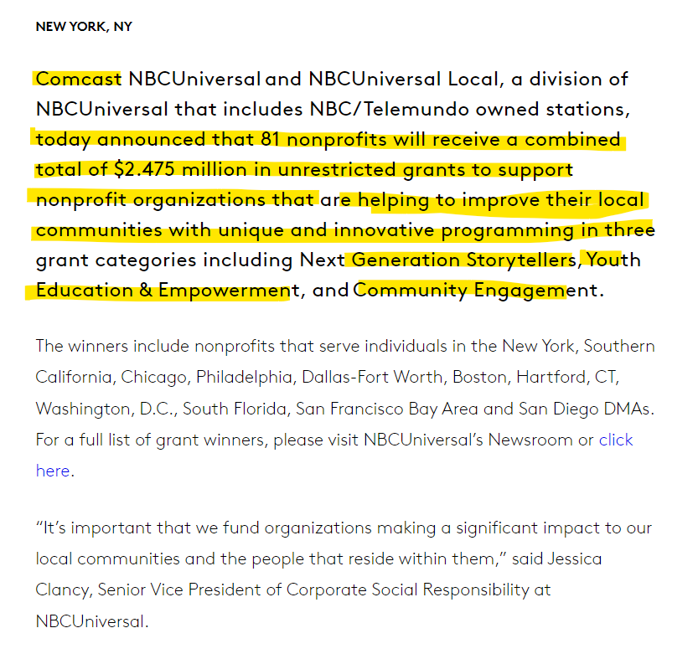

Comments-

As we can see from the snippet above, Comcast is providing grants to support nonprofit organizations that help local communities. Based on this information, we can categorize this initiative as 'Social Responsibility Initiatives

Example- 2

CID- 0C000007QC

Company Name- Ford Motor company

Link- <https://corporate.ford.com/articles/community/mobility-solutions-that-expand-access-to-food.html>

Snip

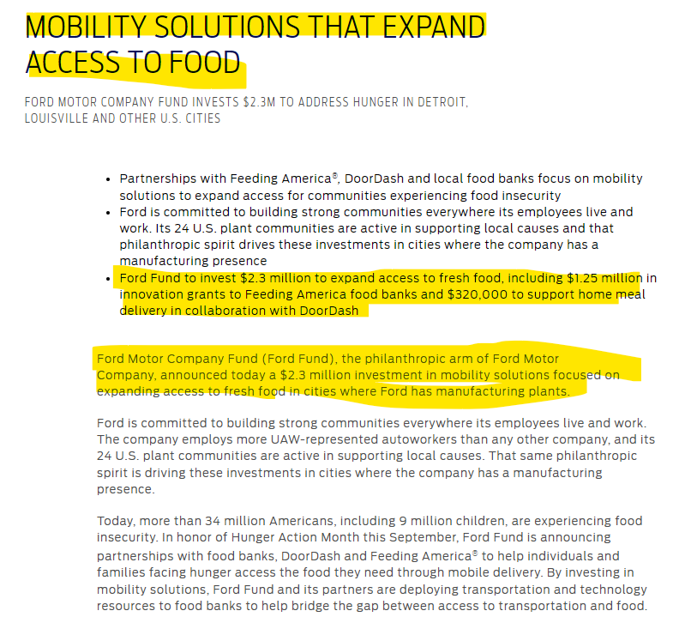

Comments-

As we can see from the snippet above, Ford Fund investment of 2.3M to address hunger in the cities. Based on this information, we can categorize this initiative as 'Social Responsibility Initiatives

**Subcategory 2**

## 2.2 Environmental Conservation Programs

Definition-

Information regarding programs and activities designed to minimize the company's environmental footprint, emphasizing sustainable practices and conservation efforts. This can include energy-efficient initiatives, waste reduction strategies, and commitments to renewable energy sources.

Example-1

CID- 0C00000PT3

Company Name- T-Mobile US Inc

Link- [T-Mobile - T-Mobile Announces 2040 Net-Zero Commitment](https://investor.t-mobile.com/events-and-presentations/news/news-details/2023/T-Mobile-Announces-2040-Net-Zero-Commitment/default.aspx)

Snip

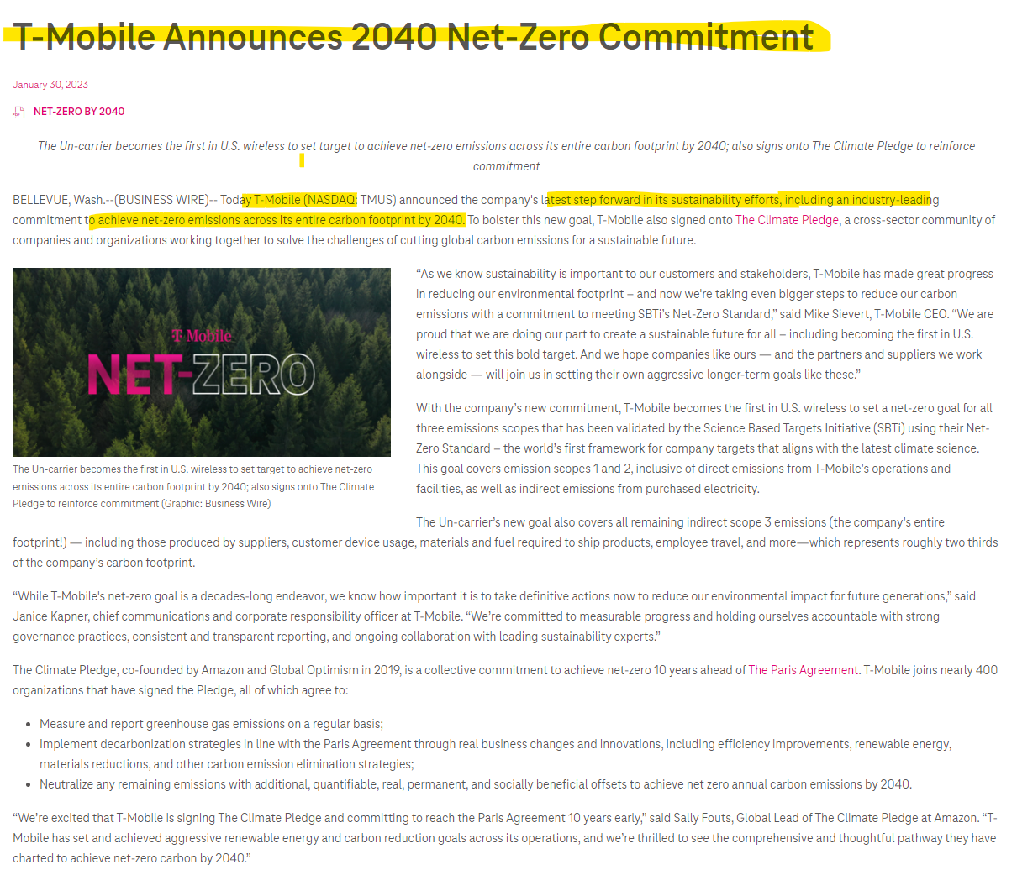

Comments-

In this press release, the company is announcing its commitment to achieving net zero carbon footprints. With the help of the above-highlighted portion from the snippet, we can categorize this event as ‘Environmental Conservation Programs’.

**Subcategory 3**

## 2.3 ESG Reporting and Compliance

This subcategory outlines the company's commitment to Environmental, Social, and Governance (ESG) principles, focusing on reporting practices and adherence to ESG standards.

Example-1

CID- 0C00000BTL

Company Name- Newmont Corp

Link-

[Newmont Corporation - Newmont Publishes 2022 Climate Report](https://www.newmont.com/investors/news-release/news-details/2023/Newmont-Publishes-2022-Climate-Report/default.aspx)

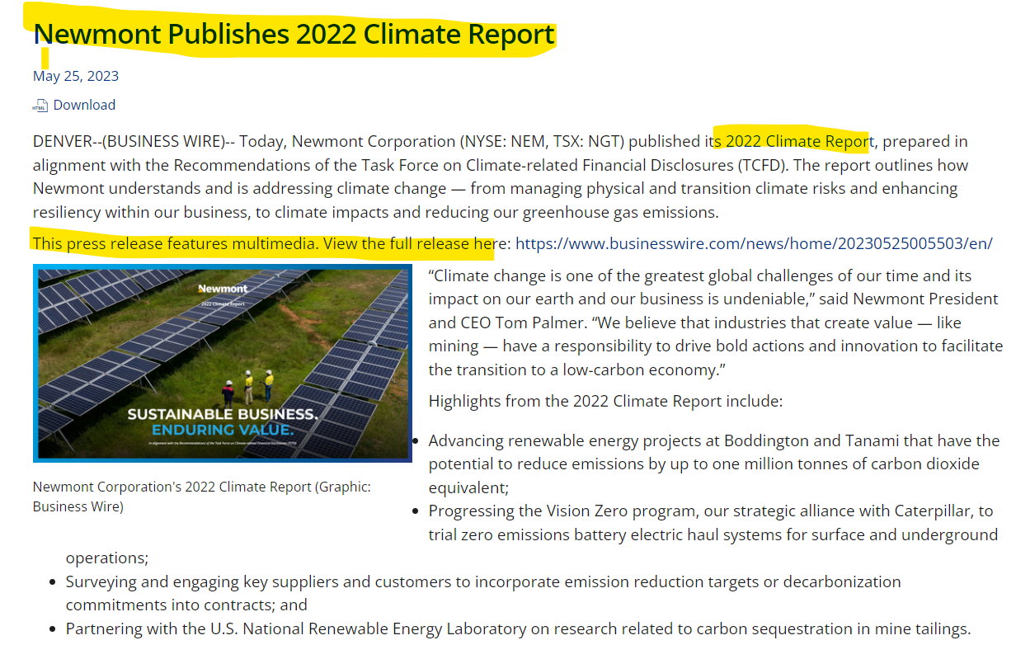

Comment-

The company is filing the above press release to inform that the company has published their 2022 Climate Report. With the help above highlighted portion from the snip we can categories this event as ‘ESG Reporting and Compliance ‘.

Example-2

CID- 0C0000AYFN

Company Name- PayPal Holdings

Link-

[PayPal Holdings, Inc. - PayPal Releases 2021 Global Impact Report (pypl.com)](https://investor.pypl.com/news-and-events/news-details/2022/PayPal-Releases-2021-Global-Impact-Report/default.aspx)

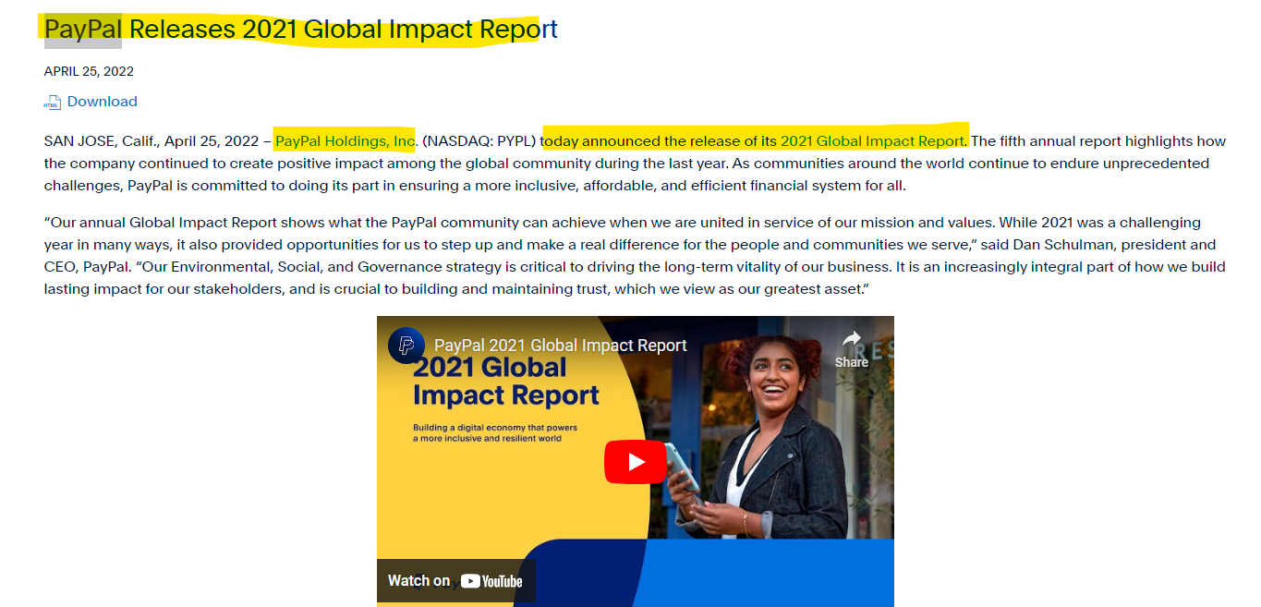

Comment-The company is filing the above press release to inform that the company has published their 2022 ‘Global Impact report. With the help of that we can categories this event as ‘ESG Reporting and Compliance ‘.

**Subcategory 4**

## 2.4 Recognition for Sustainability

Definition-

Highlights awards and recognitions received by the company for its sustainable practices, showcasing its positive impact on the environment and society.

Example-1

CID- 0C000008A8

Company Name- S&P Global Inc

Link- <https://press.spglobal.com/2023-11-13-S-P-Global-Recognized-Among-Americas-Greenest-Companies-by-Newsweek>

Snip-

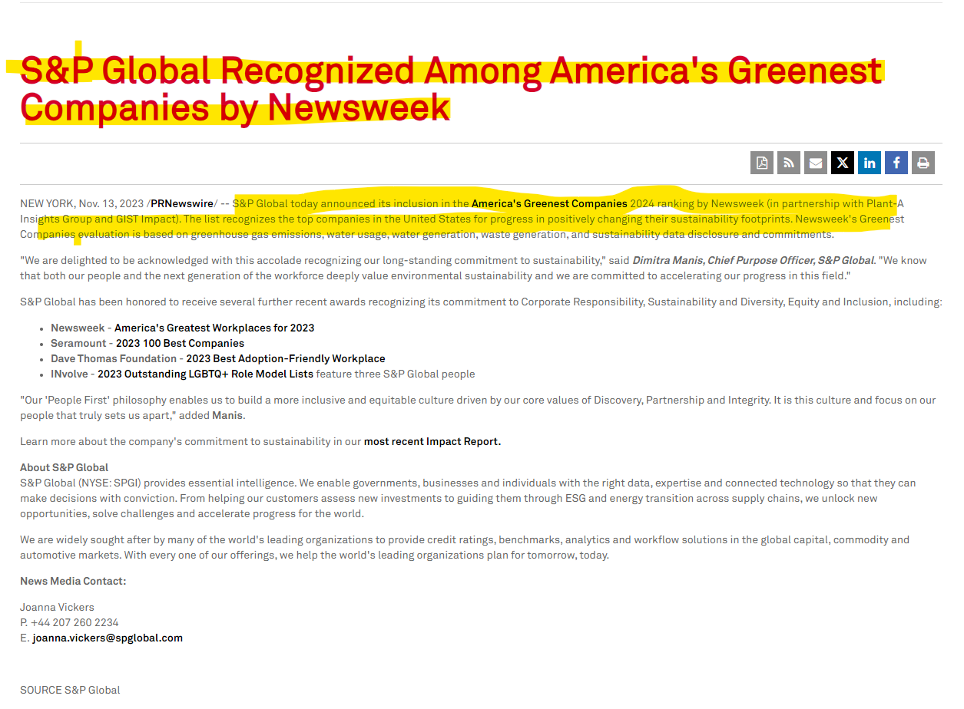

Comment-

Based on the highlighted portion from the above snippet, where the company is recognized with awards by Newsweek, we can categorize this event as 'Recognition for Sustainability'.

Example-2

CID- 0C00000CM3

Company Name- Tetra Tech, Inc.

Link- [Tetra Tech, Inc. - Tetra Tech Receives Six Environment and Climate Change Awards](https://investor.tetratech.com/press-releases/news-details/2023/Tetra-Tech-Receives-Six-Environment-and-Climate-Change-Awards/default.aspx)

Snip-

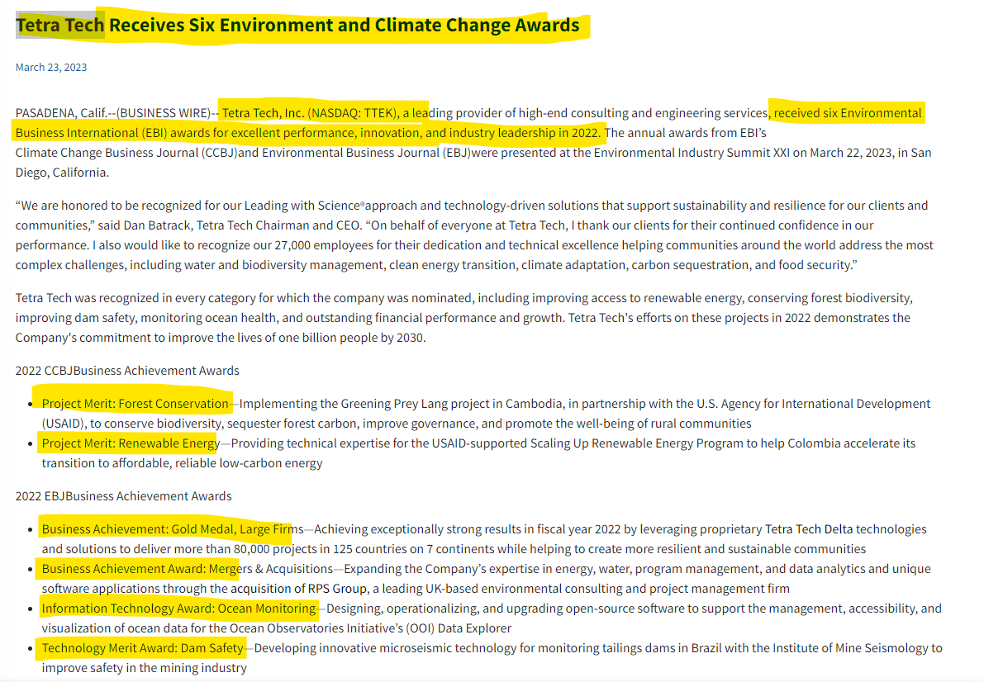

Comments-

Based on the highlighted portion from the above snippet, where the company is recognized with six s, we can categorize this event as 'Recognition for Sustainability'.

# Capital Transactions

Capital transactions refer to the processes through which companies secure financing and manage their financial responsibilities. This includes activities like selling shares to raise funds, borrowing money, paying off debts, and redemption of shares. These transactions are essential for companies to acquire capital, meet financial obligations, and maintain a healthy financial position.

Below are the sub-categories of Capital transactions-

1. Issuance of shares
2. Issuance of Debt
3. Credit Agreements
4. Redemption of Debt
5. Redemption of Shares

Examples of sub-categories within the Main category of Capital transactions.

**Subcategory 1**

## 3.1 Issuance of shares

Definition-

Announcements regarding the issuance of new shares, often undertaken to raise additional capital for the company.

Example-1

CID- 0C0000C3FV

Company Name- SkyWater Technology Inc

Link- <https://ir.skywatertechnology.com/news/news-details/2022/SkyWater-Announces-Offering-of-Shares-of-Common-Stock/default.aspx>

Snip-

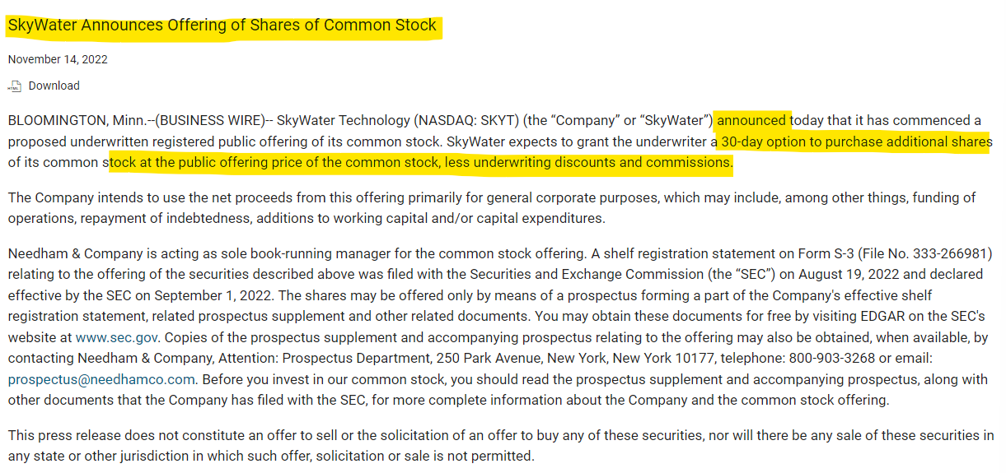

Comments-

Based on the highlighted portion from the above snippet, where the company announces the offering of shares of common stock, we can categorize this event as 'Issuance of Shares’.

Example-2

CID- 0C000008L4

Company Name- RedNet inc

Link- [RadNet Announces Closing Of Upsized Public Offering Of Common Stock | RadNet](https://www.radnet.com/about-radnet/news/radnet-announces-closing-upsized-public-offering-common-stock)

Snip-

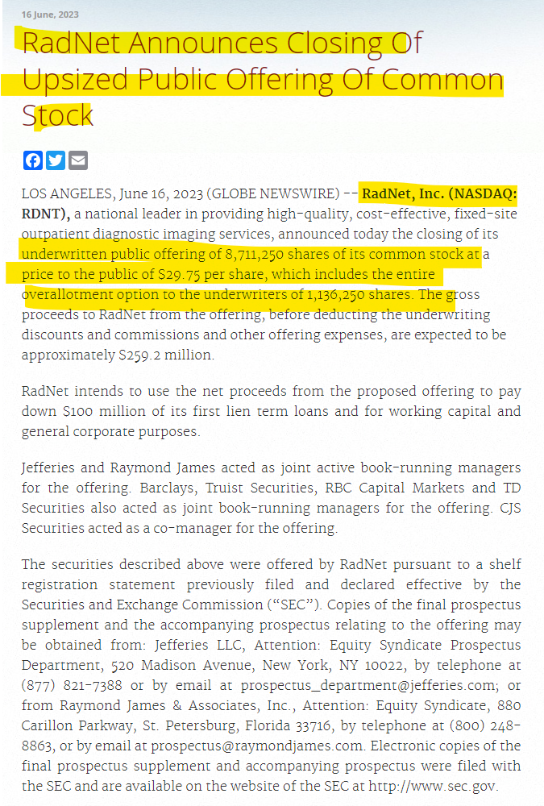

Comments-

Based on the highlighted portion from the above snippet, where the company announces the public offering of common stock, we can categorize this event as 'Issuance of Shares'.

**Subcategory 2**

## 3.2 Issuance of Debt

Definition-

Information about the issuance of debt instruments to raise capital.

Example-1

CID- 0C000008A8

Company Name- S&P Global Inc

Link- [S&P Global Announces Proposed Offering of Senior Notes (prnewswire.com)](https://www.prnewswire.com/news-releases/sp-global-announces-proposed-offering-of-senior-notes-301920716.html)

Comments-

Based on the highlighted portion from the below snippet, where the company is announcing that, the company is offering senior notes in private placement, we can categorize this event as ‘Issuance of Debt’.

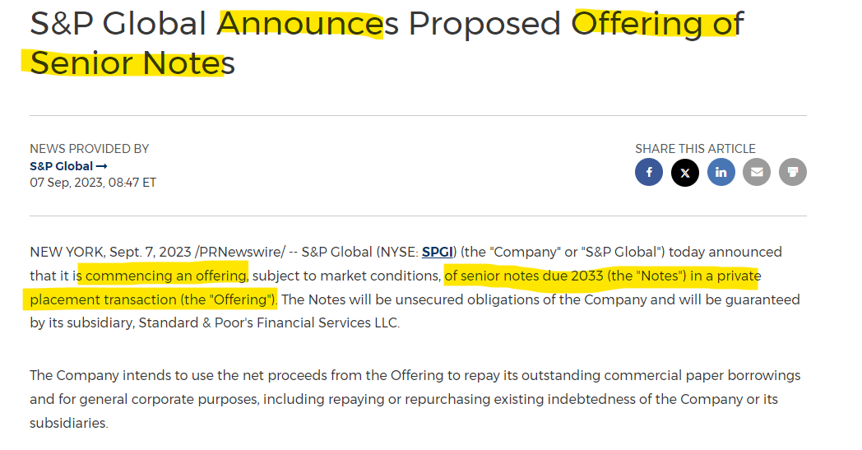

Example-2

CID- 0C00000KP8

Company Name- Mastercard Inc

Link- [Inline XBRL Viewer (sec.gov)](https://www.sec.gov/ixviewer/ix.html?doc=/Archives/edgar/data/0001141391/000119312522048521/d310935d8k.htm)

Form Type- 8-K

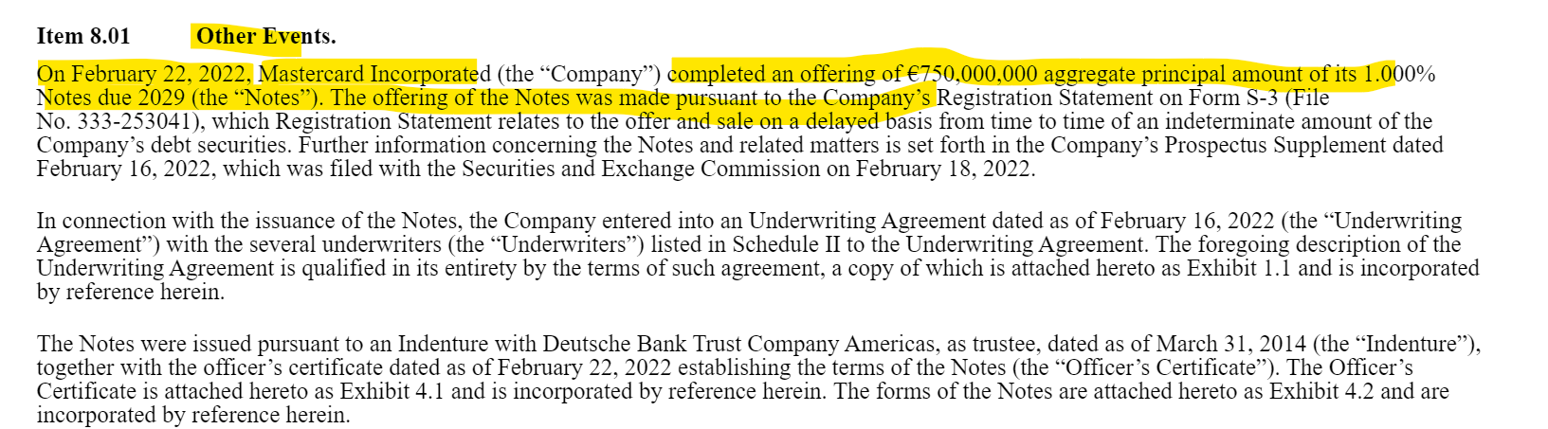

Comments-

Based on the highlighted portion from the above snippet, where the company is announcing that, the company is offering notes, we can categorize this event as ‘Issuance of Debt’.

**Subcategory 3**

## 3.3 Credit Agreements

Definition-

A credit agreement is a legally binding contract between a borrower and a lender that documents all of the terms of a loan. We will be covering all events related to credit agreements like entering into credit agreements, amending the credit agreements and terminating the credit agreement.

Example-1

CID- 0C00000KP8

Company Name- Mastercard Inc

Link- [Inline XBRL Viewer (sec.gov)](https://www.sec.gov/ixviewer/ix.html?doc=/Archives/edgar/data/0001141391/000095010322019608/dp184177_8k.htm)

Form Type 8-K

Comments-

Based on the highlighted portion from the snippet below, where we can see that the company is entering into a credit agreement, we can categorize this event as 'Credit Agreements'.

Snip-

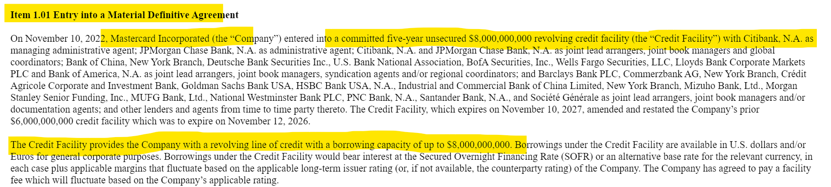

Example-2

CID- 0C00004EP4

Company Name- Tesla

Link- [Inline XBRL Viewer (sec.gov)](https://www.sec.gov/ixviewer/ix.html?doc=/Archives/edgar/data/1318605/000156459023000799/tsla-8k_20230120.htm)

Form Type 8-K

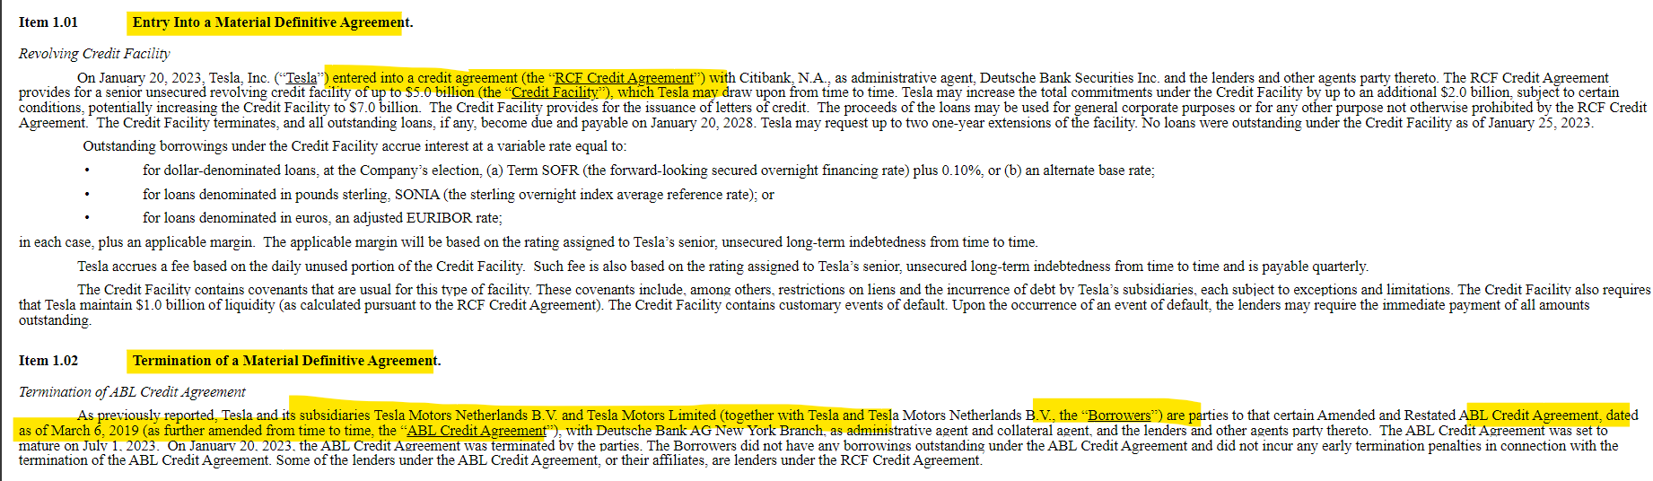

Comments-

Based on the highlighted portion from the snippet above, we can see that the company is entering into a credit agreement. Additionally, there is the termination of another credit agreement. Based on this information, we can categorize this event as 'Credit Agreements’.

**Subcategory 4**

## 3.4 Redemption of Debt

Definition-

Notifications about the redemption or repayment of debt instruments, in other words, it involves the company paying off or redeeming outstanding debt, reducing its overall debt burden.

Example-1

CID- 0C000007PC

Company Name- FLEX LTD

Link- [Inline XBRL Viewer (sec.gov)](https://www.sec.gov/ixviewer/ix.html?doc=/Archives/edgar/data/866374/000086637422000078/flex-20221116.htm)

Form Type 8-K

Snip-

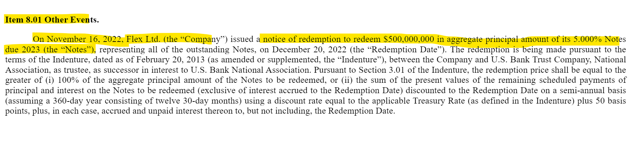

Comments-

Based on the highlighted portion from the snippet above, we can see that the company issuing notice to redeem the notes due in 2023. Based on this information, we can categorize this event as ‘Redemption of Debt’.

Example-2

CID- 0C000008DE

Company Name- MetLife

Link- [METLIFE ANNOUNCES FULL REDEMPTION OF 4.368% SERIES D SENIOR DEBENTURES](https://www.metlife.com/about-us/newsroom/2023/january/metlife-announces-full-redemption-of-4-368-series-d-senior-debentures/)

Snip-

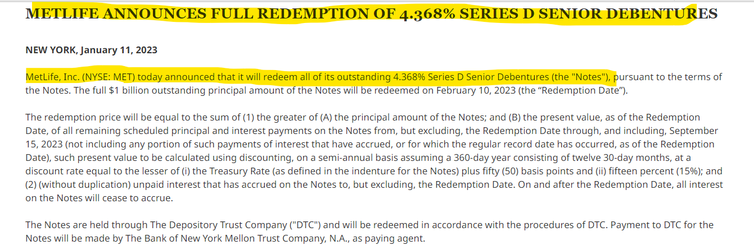

Comments-

Based on the highlighted portion from the snippet above, we can see that the company announces full redemption the debentures. Based on this information, we can categorize this event as ‘Redemption of Debt’.

**Subcategory 5**

## 3.5 Redemption of Shares

Definition-

Describes the company retiring outstanding shares, affecting shareholder equity. Share redemption may be part of capital management strategies to enhance shareholder value.

Example-1

CID- 0C00000APV

Company Name- Constellation Brands

Link- [Constellation Brands Announces Completion of Previously Announced Elimination of Class B Common Stock :: Constellation Brands, Inc. (STZ) (cbrands.com)](https://ir.cbrands.com/news-events/press-releases/detail/261/constellation-brands-announces-completion-of-previously)

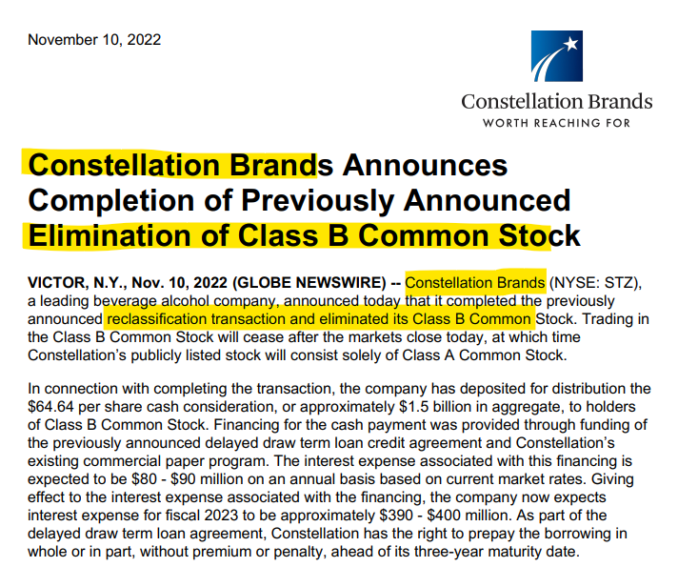

Comments-

Based on the highlighted portion from the snippet above, we can see that the company announces the elimination or cancellation of Class B common stock, signifying that the class B common stock will cease. Considering this information, we can categorize this event as ‘Redemption of Shares’.

# Equity Stake Deals

Equity stake deals refer to transactions where one company purchases a portion of another company's ownership interest, typically in the form of shares or equity or selling its own ownership in another company. These deals can involve buying or selling small or big parts of a company, depending on what the companies want to achieve.

Below are the sub-categories of Equity stake deals-

1. Stake Acq

uisition

1. Stake Sell-off

Examples of sub-categories within the Main category of Equity stake deals.

**Subcategory 1**

## 4.1 Stake acquisition

Definition-

Stake acquisition in an investee company involves one company acquiring a certain percentage of ownership in another company by purchasing shares or equity, thus becoming a shareholder with a proportional ownership interest.

Example-1

CID- 0C00000Q0G

Company Name- Blackstone Inc

Link- <https://www.businesswire.com/news/home/20230531005966/en/Blackstone-Completes-Acquisition-of-Majority-Stake-of-Copeland-Formerly-Emerson-Climate-Technologies>

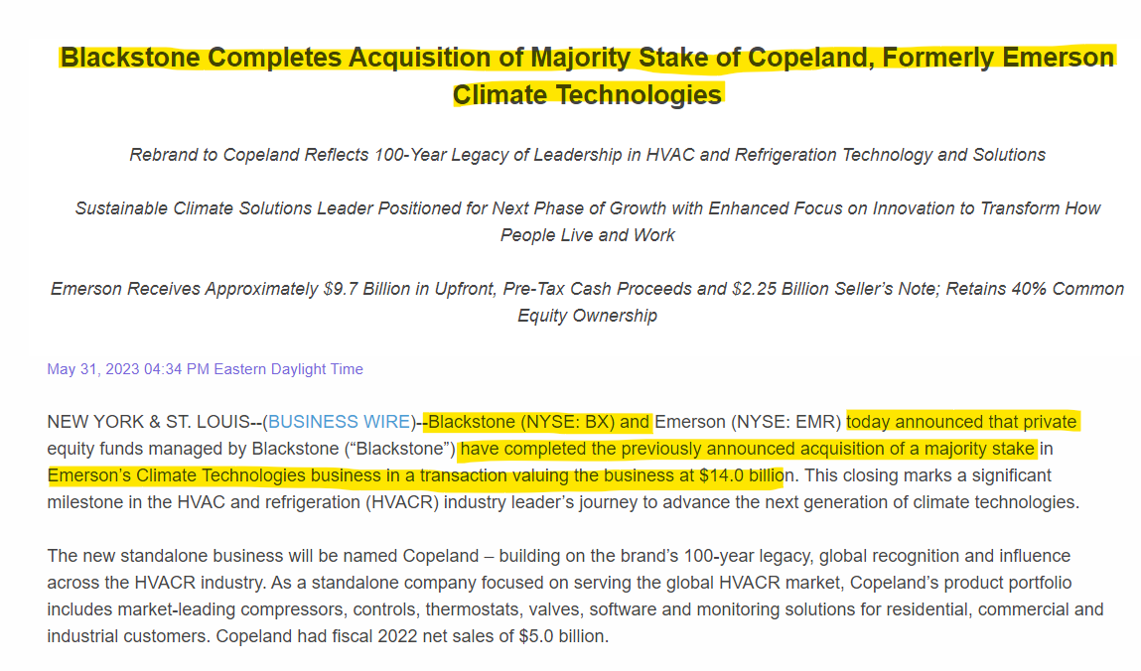

Comments-

Based on highlighted part from the above snip where Blackstone has acquired majority stake of Copeland. Hence, we can categorize this event as ‘**Stake acquisition’.**

Example-2

CID- 0C00003GMH

Company Name- DigitalBridge

Link- <https://ir.digitalbridge.com/news-releases/news-release-details/digitalbridge-investment-management-acquire-controlling-stake>

Snip**-**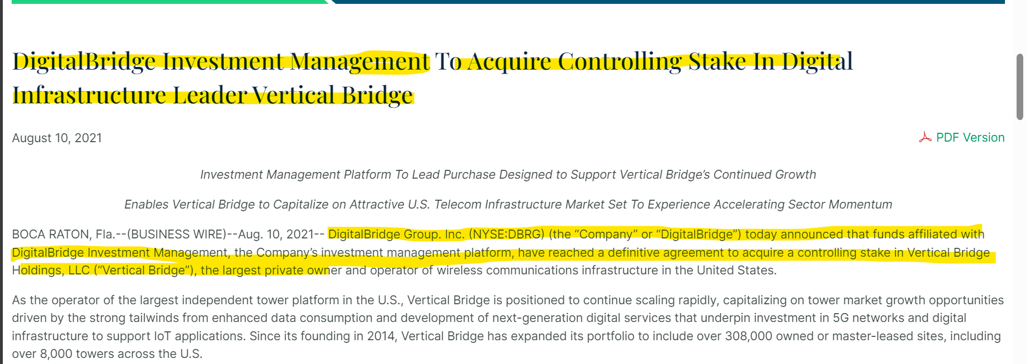

Comments-

Based on the highlighted part from the above snippet, where Digitalbridge Investment Management announced its acquisition of a controlling stake in Vertical Bridge, we can categorize this event as 'Stake Acquisition’.

**Subcategory 2**

## 4.2 Stake Sell-off

Definition-

Stake sell-off in an investee company refers to the process where a company sells a portion or all of its ownership stake in another company, which is the investee. Similarly, stake sell-off by an outside investor in a company" refers to the scenario where an external individual or entity (the outside investor) sells a portion or all of its ownership stake in a company.

Example-1

CID- 0C00000AE0

Company Name- Aramark

Link-

<https://www.businesswire.com/news/home/20230201006109/en/Aramark-to-Sell-Ownership-Stake-in-AIM-Services>

Snip-

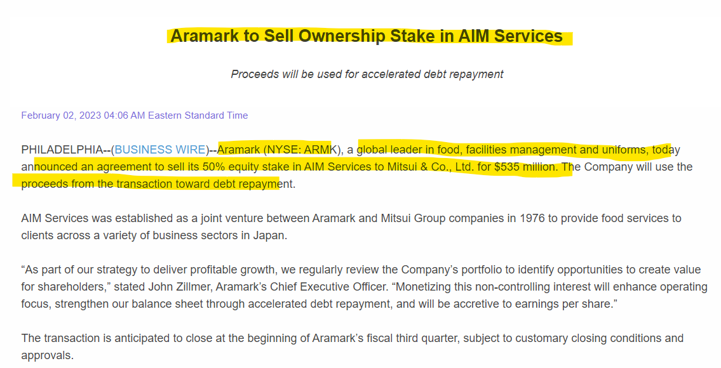

Comment-

Based on the information provided, Aramark has sold its ownership stake in AIM Services. Therefore, we can categorize this event as a 'Stake Sell-off'.

Example-2

CID- 0C00000CJQ

Company Name- TechnipFMC

Link- <https://www.technipfmc.com/en/investors/financial-news-releases/press-release/technipfmc-announces-sale-of-stake-in-technip-energies-n-v/>

Snip-

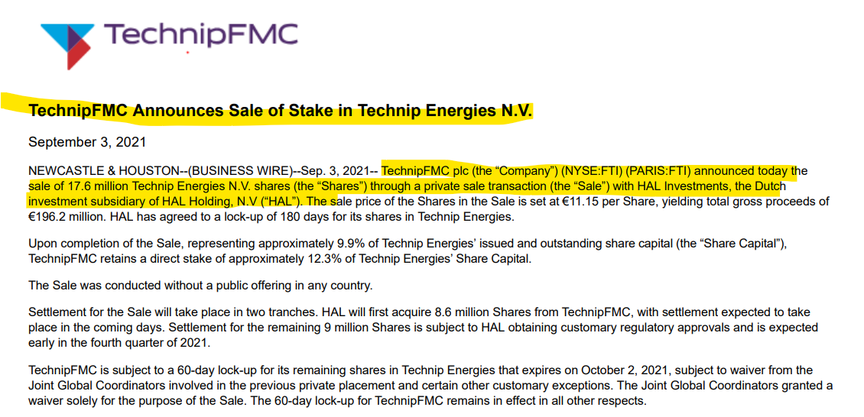

Comment-

Based on the information provided, TechnipFMC has announces sale of stake in Technip Energies. Therefore, we can categorize this event as a 'Stake Sell-off'.

# Earnings Communications

Earnings communications refer to the process through which a company communicates its financial performance and results, earnings to its stakeholders, including investors, analysts, employees, and the public.

Below are the sub-categories of earning communications-

1. Announcement of Earnings
2. Periodical Financial Reports

Examples of sub-categories within the Main category of earning communications**.**

**Subcategory 1**

## 5.1 Announcement of Earnings

Definition-

Involves formal announcements of the company's financial performance, including key metrics such as revenue, net income, and earnings per share. Earnings announcements provide a snapshot of the company's operational health and financial viability.

Example-1

CID- 0C0000098S

Company Name- Adobe Inc

Link-

<https://www.businesswire.com/news/home/20240304544440/en>

Snip-

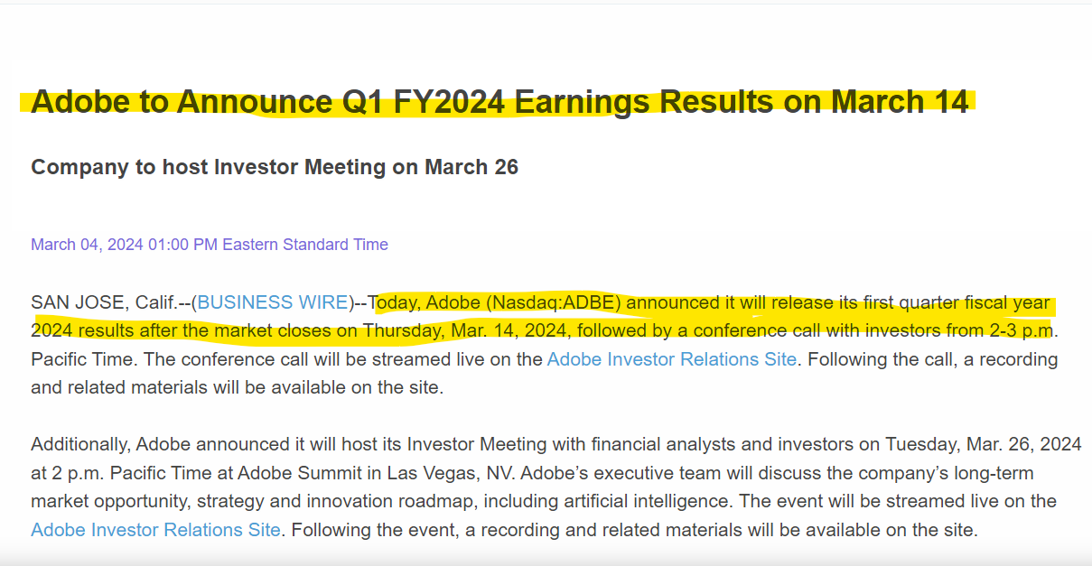

Comment-

Here, the company is filing the press release to announce its Q1 FY2024 results. Hence, we can categorize this event as 'Announcement of Earnings

Example-2

CID- 0C00000B1O

Company Name- DXP Enterprises

Link-

<https://www.businesswire.com/news/home/20240304462912/en>

Snip-

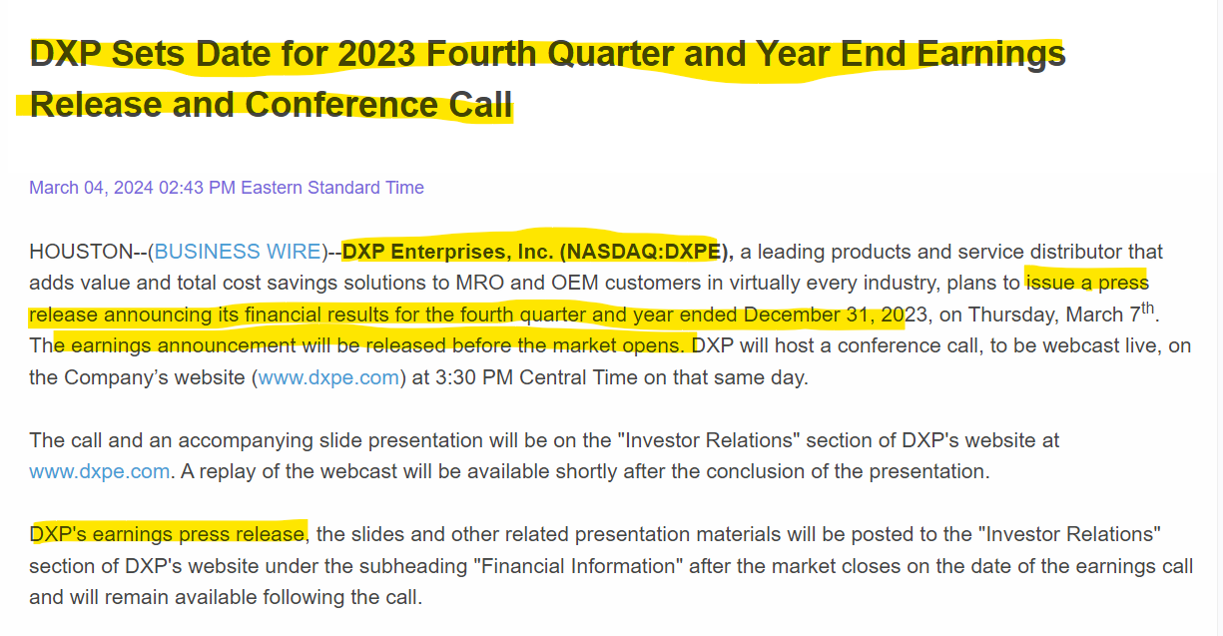

Comment-

Here, the company is filing the press release to announce its fourth quarter and full year end earnings. Hence, we can categorize this event as 'Announcement of Earnings’.

**Subcategory 2**

## 5.2 Periodical Financial Reports

Definition-

Regularly scheduled financial reports, such as quarterly and annual reports, providing comprehensive insights into the company's financial health and performance. Periodical reports include detailed financial statements, management discussions, and analysis for the benefit of investors and stakeholders.

Example-1

CID- 0C0000090J

Company Name- SFL Corp

Link-

[Repeat: SFL – Filing of Annual Report 2022 on form 20-F – Home (sflcorp.com)](https://www.sflcorp.com/repeat-sfl-filing-of-annual-report-2022-on-form-20-f/)

Snip

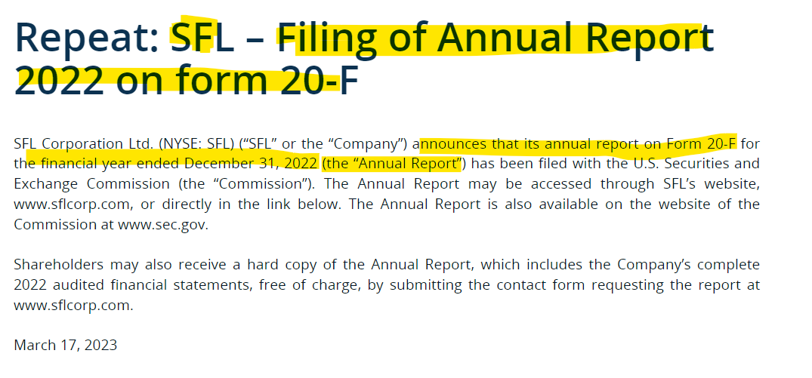

Comment-

In this press release, the company is notifying through the press release that it has filed the annual report. Hence, we can categorize this event as 'Periodical Financial Reports'.

Example-2

CID-

Company Name-

Link-

<https://www.businesswire.com/news/home/20240220614037/en/Sturm-Ruger-Company-Inc.-to-Report-2023-Results-and-File-Its-Annual-Report-on-Form-10-K-on-Wednesday-February-21>

Snip

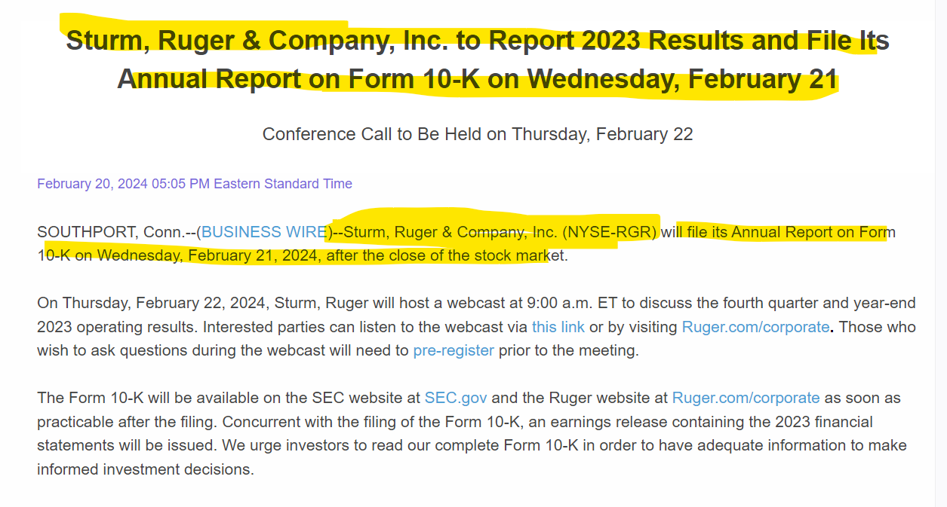

Comments-

In this press release, the company is notifying through the press release that it has filed the 10-K. Hence, we can categorize this event as 'Periodical Financial Reports'.

# 6. Corporate Actions

A corporate action is any activity that brings material change to an organization and impacts its stakeholders, including shareholders, both common and preferred, as well as bondholders.

Below are the sub-categories of corporate actions-

1. Conversion of shares
2. Conversion of Debt
3. Repurchase of shares
4. Repurchase of debt
5. Dividend Communications
6. Exchange of Notes
7. Merger and Acquisitions
8. Divestiture of Subsidiary/Division
9. Securities Listing Event
10. Stock Split
11. Reverse Stock Split
12. Spin-off
13. Right Issue
14. Ticker Symbol Update

Below are the examples of sub-categories within the Main category of corporate actions -

**Subcategory 1**

## 6.1 Conversion of shares

Definition-

Conversion of shares refers to the process by which convertible securities, such as convertible bonds or preferred shares, and other securities are exchanged or converted into a predetermined number of common shares of the issuing company.

Example-1

CID- 0C0000BMJI

Company Name- Fastly Inc

Link-

[Fastly Announces Conversion of Class B Common Stock into Class A Common Stock | Business Wire](https://www.businesswire.com/news/home/20210712005820/en/Fastly-Announces-Conversion-of-Class-B-Common-Stock-into-Class-A-Common-Stock)

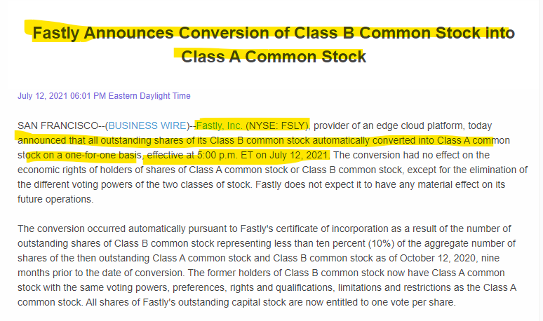

Comment-

In the given case, Fastly Corporation is issuing a press release announcing the conversion of Class B common stock to Class A common stock. Thus, we can classify this event as a 'conversion of shares'.

Example-2

CID- 0C00000PMO

Company Name-Pembina Pipeline Corp

Link-

[sec.gov/Archives/edgar/data/1546066/000115752323000119/a53293791ex99_1.htm](https://www.sec.gov/Archives/edgar/data/1546066/000115752323000119/a53293791ex99_1.htm)

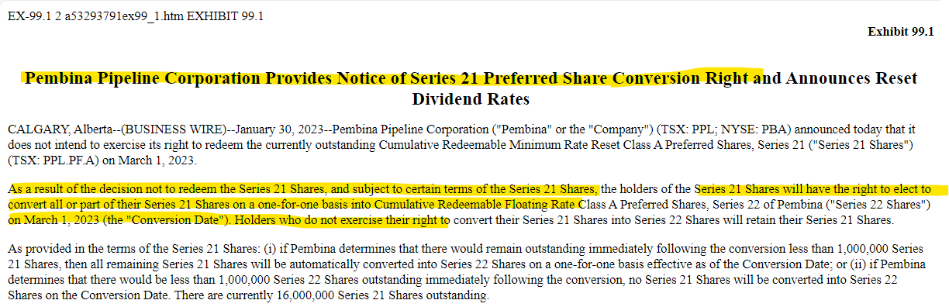

Comment-

In the provided scenario, the company is announcing via a press release the conversion of Series 21 preferred shares into Cumulative Redeemable Floating Rate Class A Preferred Shares. Consequently, we can classify this event as a 'conversion of shares'.

**Subcategory 2**

## 6.2 Conversion of Debt

Definition-

This subcategory covers the process of converting debt into equity, providing insights into the company's capital structure adjustments.

Example-1

CID- 0C00000CW2

Company Name- us bancorp

Link-

[U.S. Bancorp Announces Debt/Equity Conversion With Mitsubishi UFJ Financial Group, Inc. (MUFG) (usbank.com)](https://ir.usbank.com/files/doc_news/2023/08/News-Release-08-02-2023-1703078952900920.pdf)

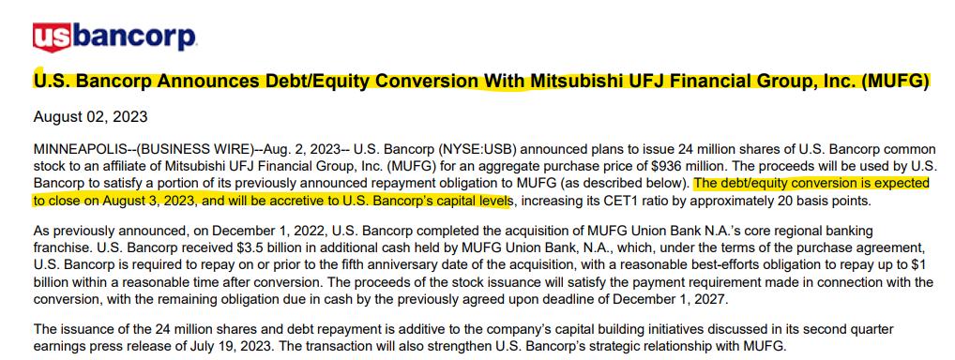

Comment-

Here the U.S company announces debt/equity conversion with the affiliates company. Hence, we can categorize this event as Conversion of Debt.

Example-2

CID- 0C0000090J

Company Name- SFL Corp Ltd

[Document (sec.gov)](https://www.sec.gov/Archives/edgar/data/1289877/000128987723000012/sflpressreleasemarch142023.htm)

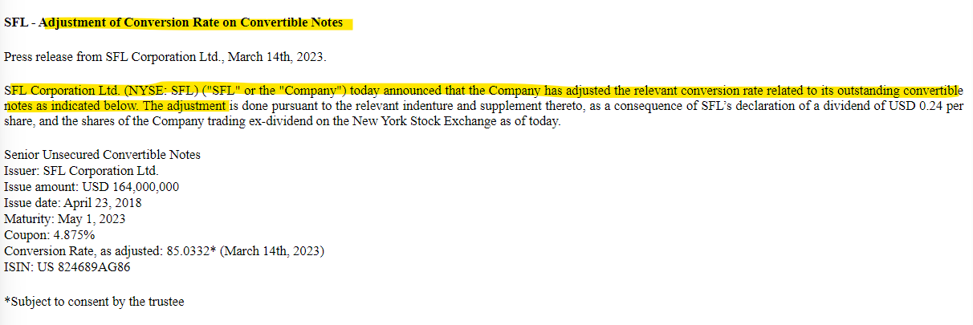

Comment-

In the excerpt above, it's mention that the company has adjusted the conversion rate pertaining to convertible notes. Such occurrences can be categorized as 'Conversion of Debt' events.

**Subcategory 3**

## 6.3 Repurchase of shares

Definition-

The repurchase of shares, also known as share buyback, is when a company buys back its own shares from the market, usually using its own funds. This reduces the number of outstanding shares in the market.

Example-1

CID- 0C0000C2ZK

Company Name- Coursera Inc

Link-

[Coursera Announces Share Repurchase Program | Business Wire](https://www.businesswire.com/news/home/20230427005929/en/)

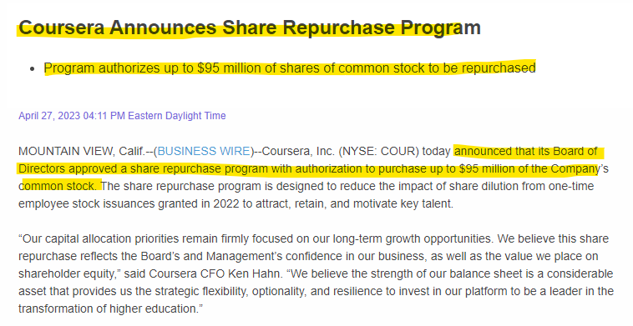

Comment-

Here the company has announced that it approved the share repurchase program. Hence, we can categorize the events as ‘Repurchase of shares’.

Example-2

CID- 0C0000A5B6

Company Name- News Corp

Link-

[News Corp Announces $1 Billion Stock Repurchase Program; Stockholder Rights Agreement Terminated | Business Wire](https://www.businesswire.com/news/home/20210922005599/en/News-Corp-Announces-1-Billion-Stock-Repurchase-Program-Stockholder-Rights-Agreement-Terminated)

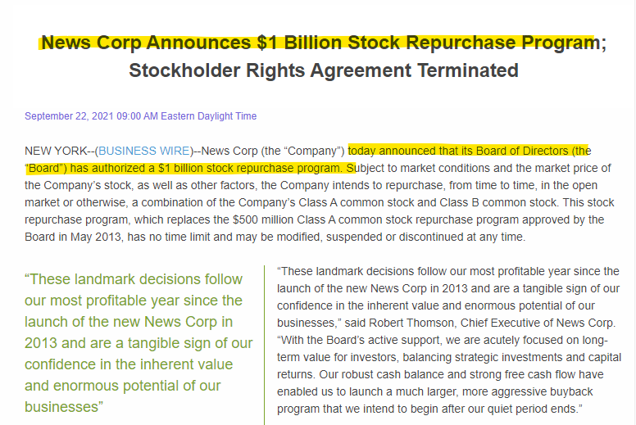

Comment-

Here the company has announced that it approved the share repurchase program. Hence, we can categorize the events as ‘Repurchase of shares.

**Subcategory 4**

## 6.4 Repurchase of Debt

Definition-

The repurchase of debt, often referred to as a "debt buyback" or "debt repurchase," is a financial transaction where a company buys back its own debt securities from investors.

Example-1

CID- 0C0000AYFN

Company Name- PayPal Holdings

Link-

[PayPal Holdings, Inc. - PayPal Announces Debt Tender Offer (pypl.com)](https://investor.pypl.com/news-and-events/news-details/2022/PayPal-Announces-Debt-Tender-Offer/default.aspx)

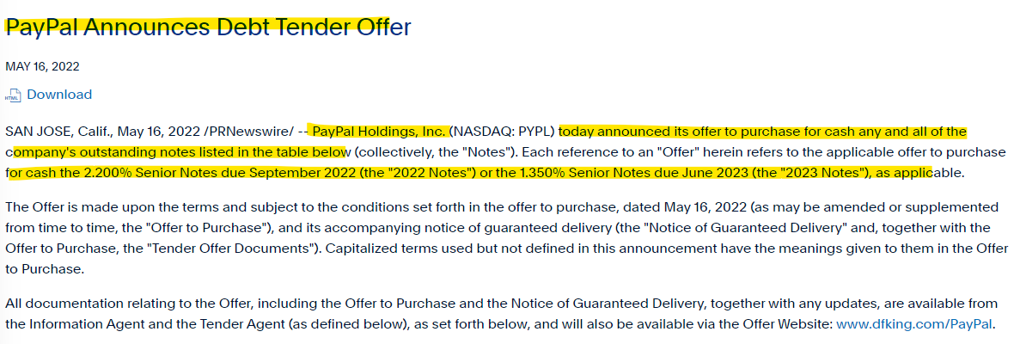

Comment-

In the highlighted portion from the above snippet, we can see that the company announced a tender to buy back its debt for cash. Hence, we can categorize this event as Repurchase of debt.

Example-2

CID- 0C00000APG

Company Name- ConocoPhillips

Link-

[ConocoPhillips Announces Upsize of Previously Announced Cash Tender Offer | ConocoPhillips](https://www.conocophillips.com/news-media/story/conocophillips-announces-upsize-of-previously-announced-cash-tender-offer/)

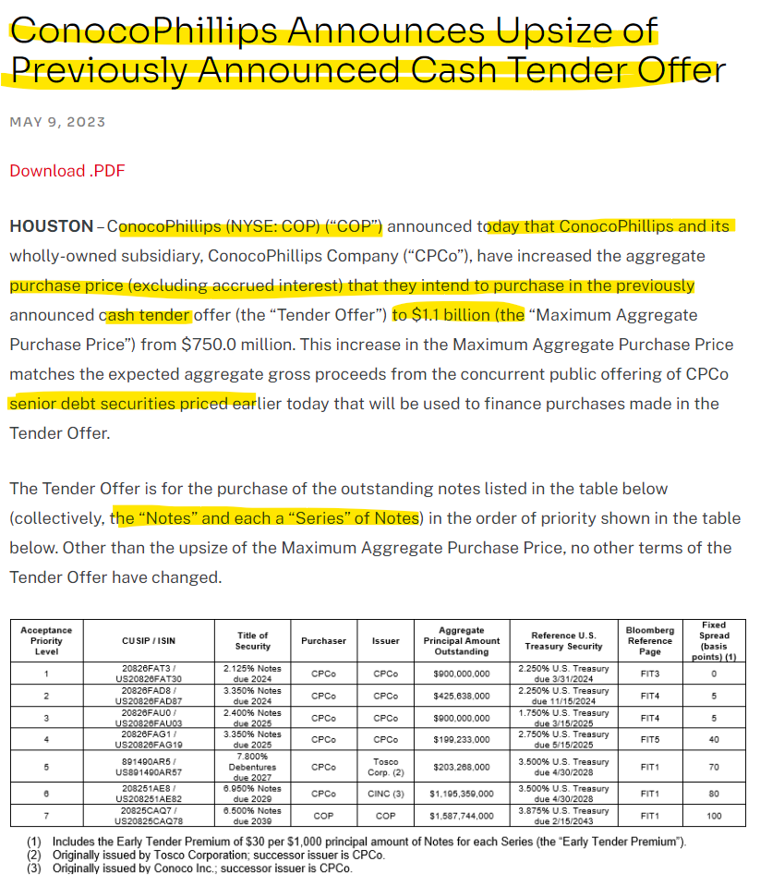

Comment-

Here in the above case, we can see that the company announced a tender offer to buy back its debt for cash. Hence, we can categorize this event as a debt repurchase.

**Subcategory 5**

## 6.5 Dividend Communications

Definition-

Dividend communications refer to the announcements, or disclosures made by a company to its shareholders regarding the distribution of dividends. These communications typically include information about the amount of the dividend, the payment date, the record date and any other relevant details regarding the dividend policy of the company.

Example-1

CID- 0C00000CW2

Company Name- U.S. Bancorp S

Link-

[U.S. Bancorp Announces Quarterly Dividends | Business Wire](https://www.businesswire.com/news/home/20210914006169/en/U.S.-Bancorp-Announces-Quarterly-Dividends)

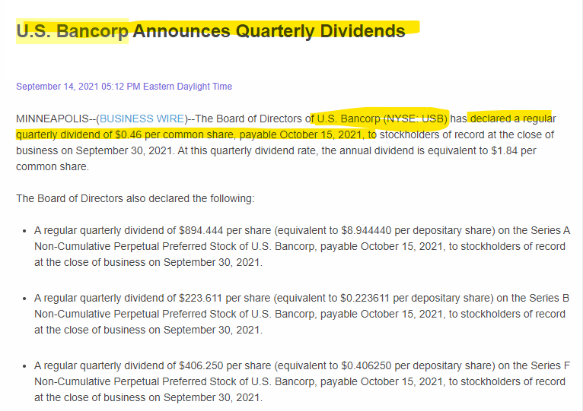

Comments-

Here, in the above case, we can see that the company is informing through the press release regarding the dividend payment on common stock. Therefore, we can categorize this event as "dividend communication.

Example-2

CID- 0C000008A8

Company Name- S&P Global Inc

Link-

[S&P Global Declares Third Quarter Dividend - S&P Global (spglobal.com)](https://investor.spglobal.com/news-releases/news-details/2023/SP-Global-Declares-Third-Quarter-Dividend/default.aspx)

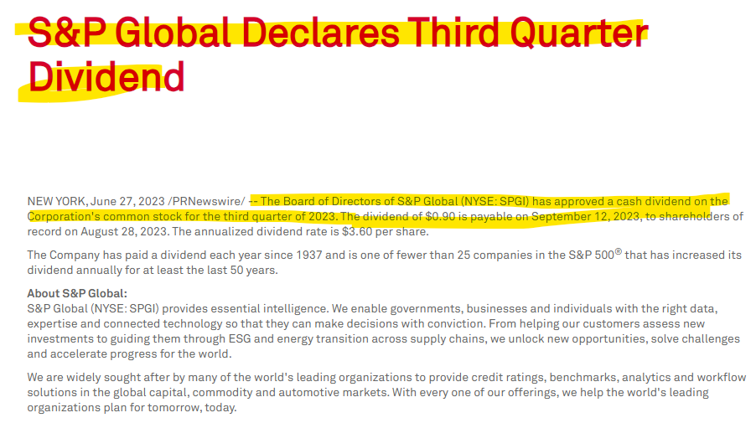

Comments-

The company is notifying that they have declares the dividend for the third quarter in the above press release. Hence, we can categorize the above events as dividend communication.

**Subcategory 6**

## 6.6 Exchange of Notes

Definition-

This sub-category of financial communication focuses on the exchange of financial notes or instruments. It provides details about changes in terms or conditions related to the exchange, such as refinancing, interest rate adjustments, or payment schedule modifications.

Example-1

CID- 0C00000BIQ

Company Name- Intercontinental Exchange

Link-

[Intercontinental Exchange - Intercontinental Exchange, Inc. Announces Expiration of Exchange Offer for Black Knight InfoServ, LLC’s Outstanding 3.625% Senior Notes due 2028 (theice.com)](https://ir.theice.com/press/news-details/2023/Intercontinental-Exchange-Inc.-Announces-Expiration-of-Exchange-Offer-for-Black-Knight-InfoServ-LLCs-Outstanding-3.625-Senior-Notes-due-2028/default.aspx)

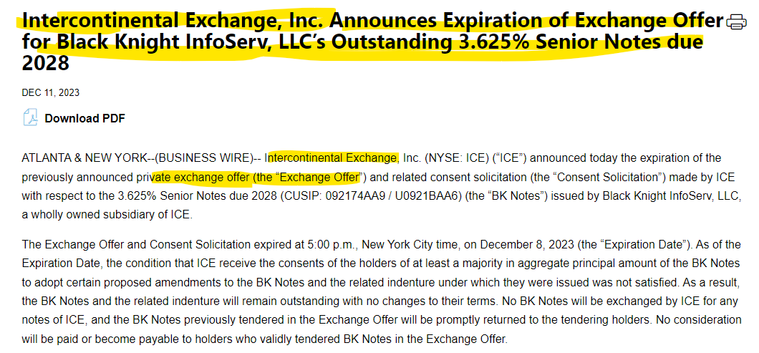

Comments-

Here, the company is announcing the expiration of an exchange offer for senior notes. As a result, we can classify this event as an "exchange of notes."

Example-2

CID- 0C0000AK73

Company Name- Sabre Corporation

Link-

[Sabre Corporation Announces Settlement of the Exchange Offers for Certain Senior Secured Debt Securities Due 2025 and Issuance of New Notes Due 2027 (prnewswire.com)](https://www.prnewswire.com/news-releases/sabre-corporation-announces-settlement-of-the-exchange-offers-for-certain-senior-secured-debt-securities-due-2025-and-issuance-of-new-notes-due-2027-301921289.html)

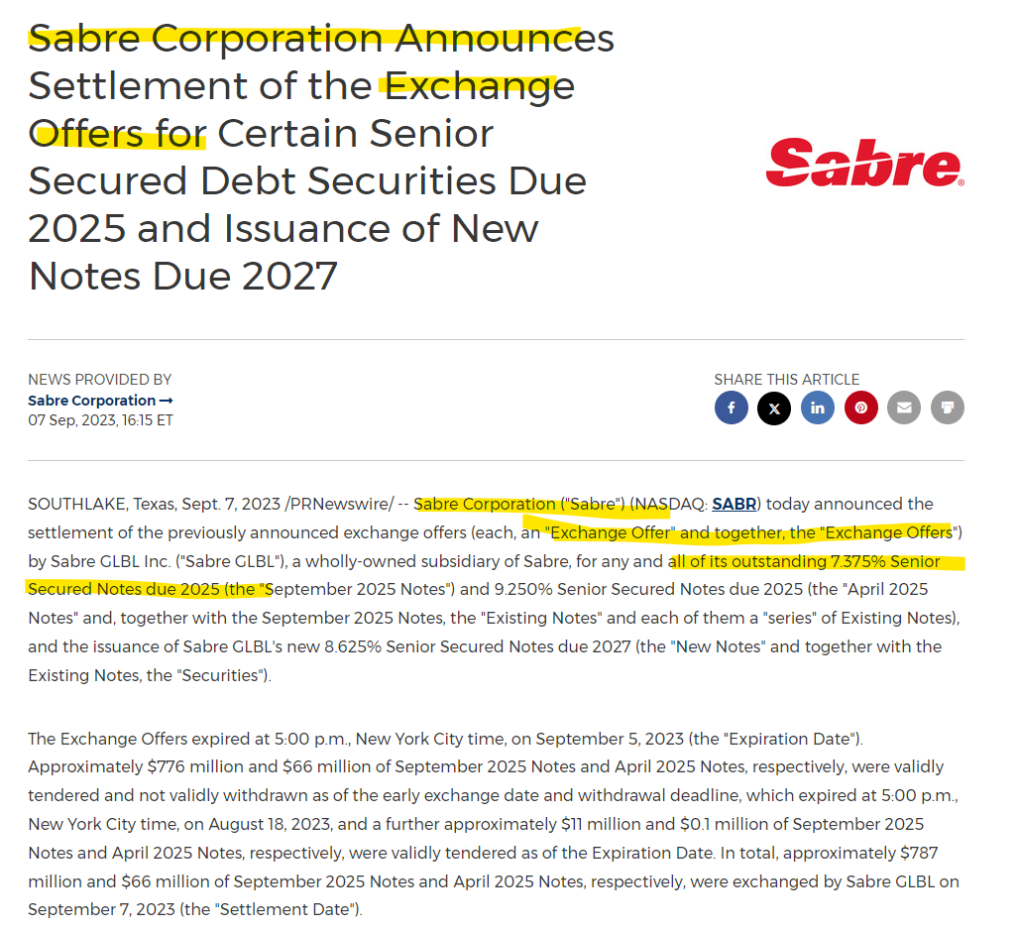

Comment-

Here, the company is announcing the settlement of an exchange offer on certain senior secured debt securities. Therefore, we can categorize this event as an "exchange of notes."

## 6.7 Merger and Acquisitions

Definition-

Addresses updates related to mergers, acquisitions, or significant business combinations, shedding light on strategic moves and potential impacts.

Example-1

CID- 0C00000BDL

Company Name-IBM

Link-

[IBM Completes Acquisition of Apptio Inc. (prnewswire.com)](https://www.prnewswire.com/news-releases/ibm-completes-acquisition-of-apptio-inc-301898036.html)

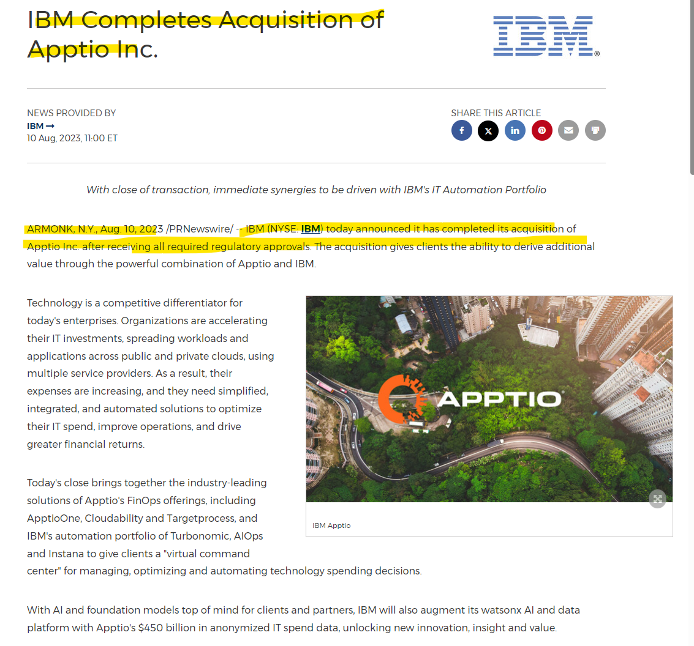

Comment-

The company is notifying via this press release that they have completed the acquisition of Apptio inc. Hence, we can categorize this event as Merger and Acquisitions.

Example-2

CID- 0C00000VF2

Company Name- Visa

Link-

[Visa Inc. - Visa to Acquire Pismo](https://investor.visa.com/news/news-details/2023/Visa-to-Acquire-Pismo/default.aspx)

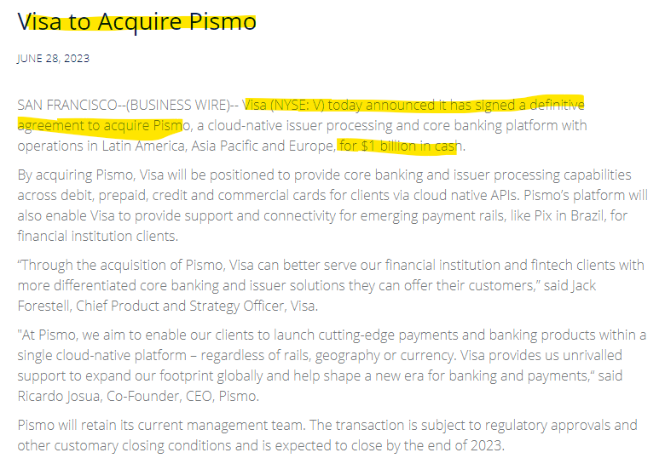

Comments-

The company is notifying via this press release that they have completed the acquisition of Apptio inc. Hence, we can categorize this event as Merger and Acquisitions.

**Subcategory 8**

## 6.8 Divestiture of

## diary/Division

Definition-

Divestiture of a subsidiary or division refers to the process of a company selling off or disposing of one of its smaller, separate entities or segments.

Example-1

CID- 0C00000987

Company Name- Enerpac Tool Group

Link-

[Enerpac Tool Group Announces Definitive Agreement to Sell Cortland Industrial to Tufropes :: Enerpac Tool Group Corp. (EPAC)](https://ir.enerpactoolgroup.com/news-events/press-releases/detail/228/enerpac-tool-group-announces-definitive-agreement-to-sell)

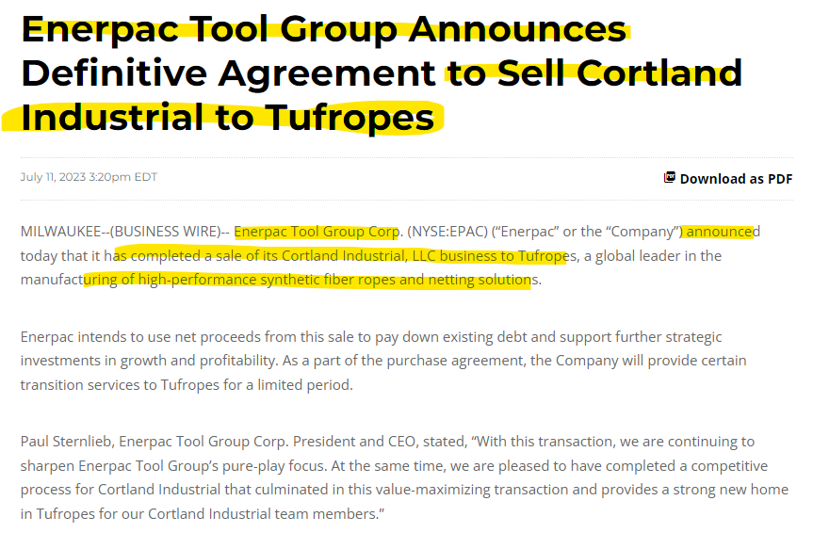

Comments-

Here, the company is announcing the sale of Cortland Industrial to Tufropes. The company is divesting its division to another company. Therefore, we can categorize this event as a "divestiture of subsidiary/division."

Example-2

CID- 0C000008A8

Company Name- S&P Global Inc

Link-

[S&P Global Completes Sale of Engineering Solutions Business - S&P Global (spglobal.com)](https://investor.spglobal.com/news-releases/news-details/2023/SP-Global-Completes-Sale-of-Engineering-Solutions-Business/default.aspx)

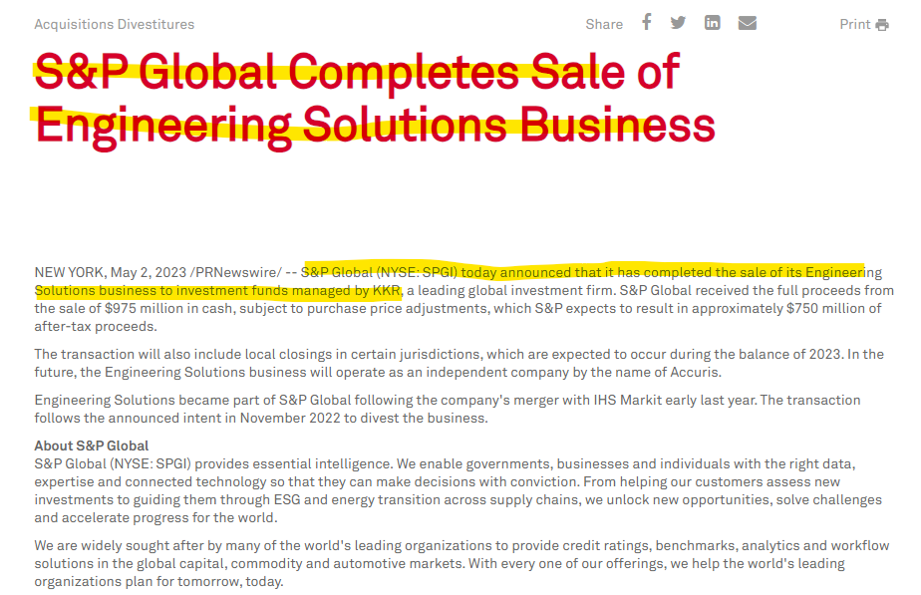

Comments-

Here, S&P is announcing the sale of its engineering solutions business to an investment trust. Therefore, we can categorize this event as a "divestiture of subsidiary/division."

**Subcategory 9**

## 6.9 Securities Listing Event

Definition-

Announcements related to the listing/delisting/relisting/cross listing of securities on stock exchanges fall under this sub-category.

Example-1

CID- 0C00000ASP

Company Name- CRH plc

Link-

[transition-to-us-primary-listing-complete.pdf (crh.com)](https://www.crh.com/media/4935/transition-to-us-primary-listing-complete.pdf)

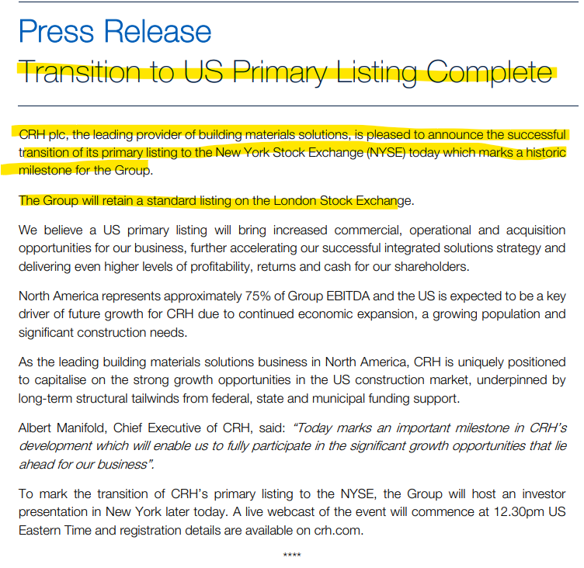

Comment-

Here, the company is informing that they have secured their listing on the New York Stock Exchange. Therefore, we can tag this event as a "Securities Listing Event."

**Subcategory 10**

## 6.10 Stock Split

Definition-

A stock split is when a company divides its existing shares into multiple shares. This doesn't change the total value of an investor's holdings but increases liquidity and makes shares more affordable to smaller investors.

Example-1

CID- 0C00004EP4

Company Name- Tesla

Link-

[Tesla Announces a Three-for-One Stock Split | Business Wire](https://www.businesswire.com/news/home/20220805005007/en/Tesla-Announces-a-Three-for-One-Stock-Split)

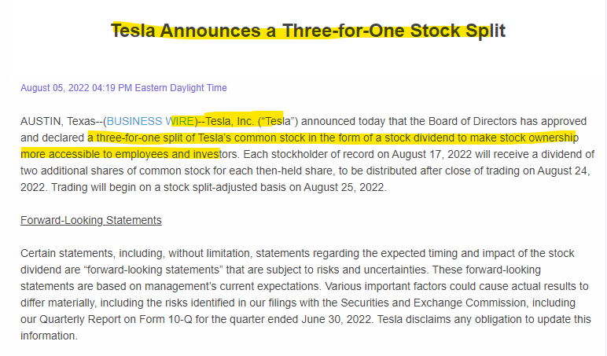

Comment-

In the above press release, Tesla is announcing a 3-for-1 stock split of the company's common stock. Hence, we can categorize this event as a "stock split."

Example-2

CID- 0C000007TH

Company Name- GameStop

Link-

[GameStop Announces Four-for-One Stock Split | Business Wire](https://www.businesswire.com/news/home/20220706005665/en/GameStop-Announces-Four-for-One-Stock-Split)

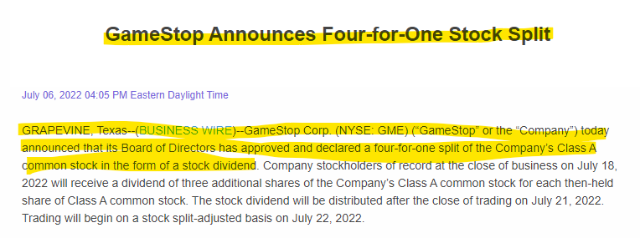

Comment-

In the above press release, GameStop company is announcing a 4-for-1 stock split of the company’s class A common stock. Hence, we can categorize this event as a "stock split."

**Subcategory 11**

## 6.11 Reverse stock split

Definition-

A reverse stock split is a corporate action where a company reduces the number of its outstanding shares, consolidating them into fewer shares. This typically increases the price per share but does not change the overall value of the company.

Example-1

CID- 0C0000C9IT

Company Name- Wework

Link-

[WeWork Inc. Announces Completion of 1-for-40 Reverse Stock Split | Business Wire](https://www.businesswire.com/news/home/20230901569092/en/)

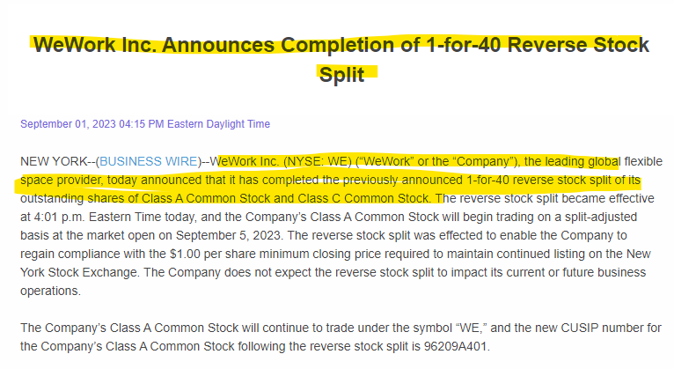

Comment-

In the above press release, WeWork company announced a 1-for-40 reverse stock split of the company’s class A and Class C common stock. Hence, we can categorize this event as a "reverse stock split."

Example- 2

CID- 0C0000CBNY

Company Name- Sidus Space

Link-

[Sidus Space Announces 1-for-100 Reverse Stock Split | Business Wire](https://www.businesswire.com/news/home/20231218891635/en/Sidus-Space-Announces-1-for-100-Reverse-Stock-Split)

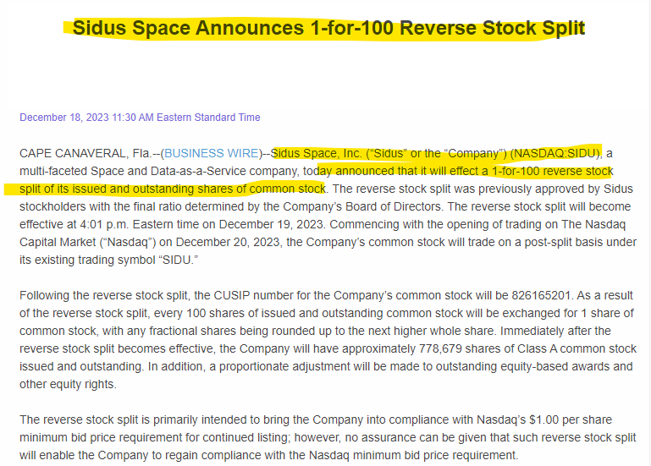

Comment-

In the above press release, Sidus Space company announced a 1-for-100 reverse stock split of the company’s common stock. Hence, we can categorize this event as a "reverse stock split."

**Subcategory 12**

## 6.12 Spin-off

Definition-

A spin-off is a new company or business unit created from an existing company's assets or operations. It typically involves separating a portion of the original company to operate independently, often with its own management, resources, and objectives. Spin-offs are usually done to unlock value, focus on core operations, or pursue growth opportunities in specific areas.

Example-1

CID- 0C00000AS8

Company Name- Crane Co

Link-

[Crane Co. Announces Intention to Separate into Two Independent, Publicly Traded Companies | Business Wire](https://www.businesswire.com/news/home/20220329005840/en/Crane-Co.-Announces-Intention-to-Separate-into-Two-Independent-Publicly-Traded-Companies)

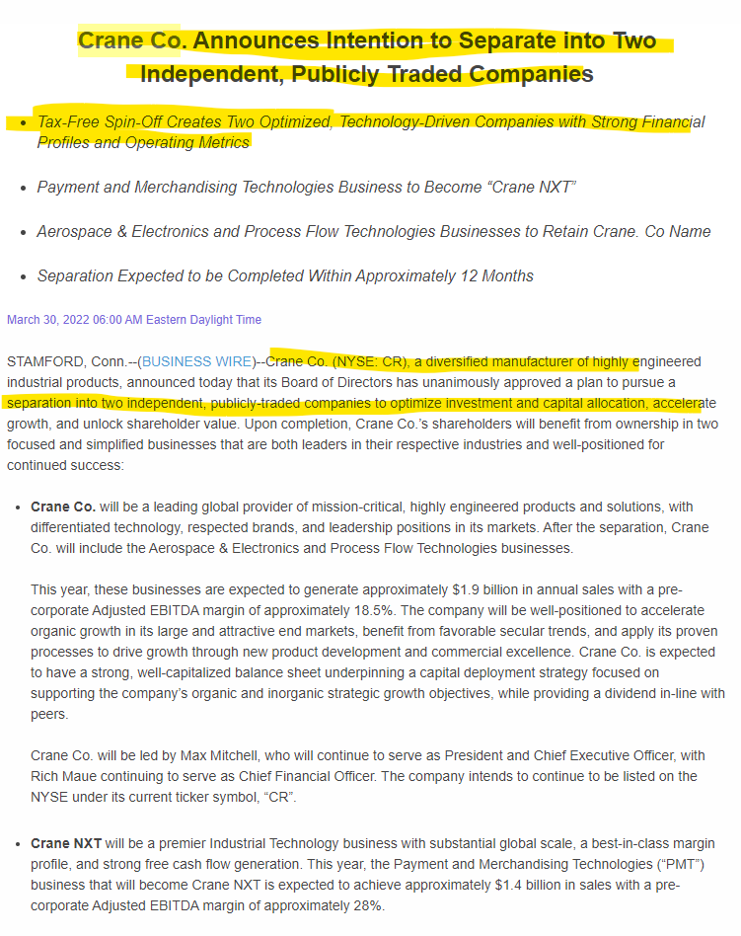

Comment-

Here, Crane Co. announces its intention to spin off by creating two independent publicly traded companies. Therefore, we can categorize this news as a "spin-off."

Example-2

CID-

Company Name- Aramark

Link-

[Aramark Completes Spin-Off of Vestis™ | Business Wire](https://www.businesswire.com/news/home/20231002711764/en/Aramark-Completes-Spin-Off-of-Vestis%E2%84%A2)

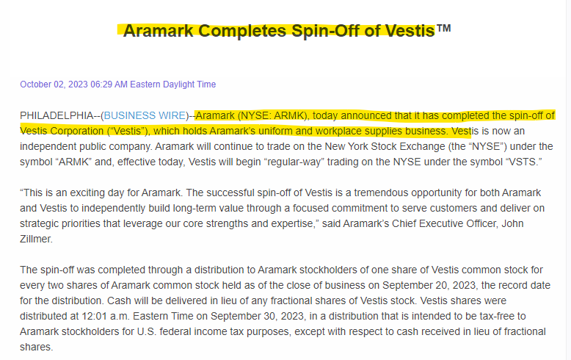

Comment-

Here, Aramark company announced that it has completed the spin-off of Vestie Corporation. Therefore, we can categorize this news as a "spin-off."

**Subcategory 13**

## 6.13 Right Issue

Definition-

A right issue, also known as a right offering, is a method used by a company to raise capital by offering its existing shareholders the opportunity to purchase additional shares of the company's stock at a discounted price, typically in proportion to their existing holdings. This allows current shareholders to maintain their proportional ownership in the company and potentially increase their investment at a favorable price.

Example-1

CID- 0C0000081X

Company Name- Distribution Solutions Group

Link-

[Distribution Solutions Group Announces Plan to Undertake Rights Offering | DSG (lawsonproducts.com)](https://investor.lawsonproducts.com/news-releases/news-release-details/distribution-solutions-group-announces-plan-undertake-rights)

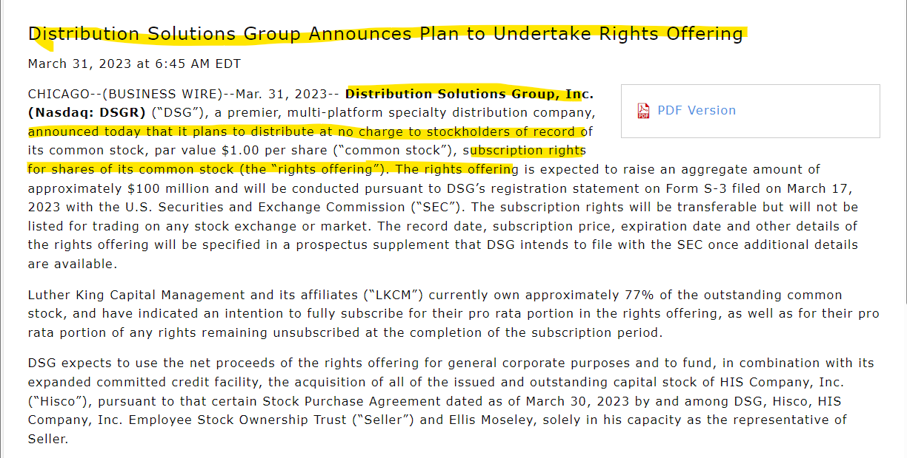

Comment-

Here, the company "Distribution Solutions Group" is announcing a rights offering. Hence, we can tag this event under the "rights issue" category.

Example-2

CID- 0C00000BV2

Company Name- Nordstrom

Link-

<https://www.prnewswire.com/news-releases/nordstrom-adopts-limited-duration-shareholder-rights-plan-301628071.html>

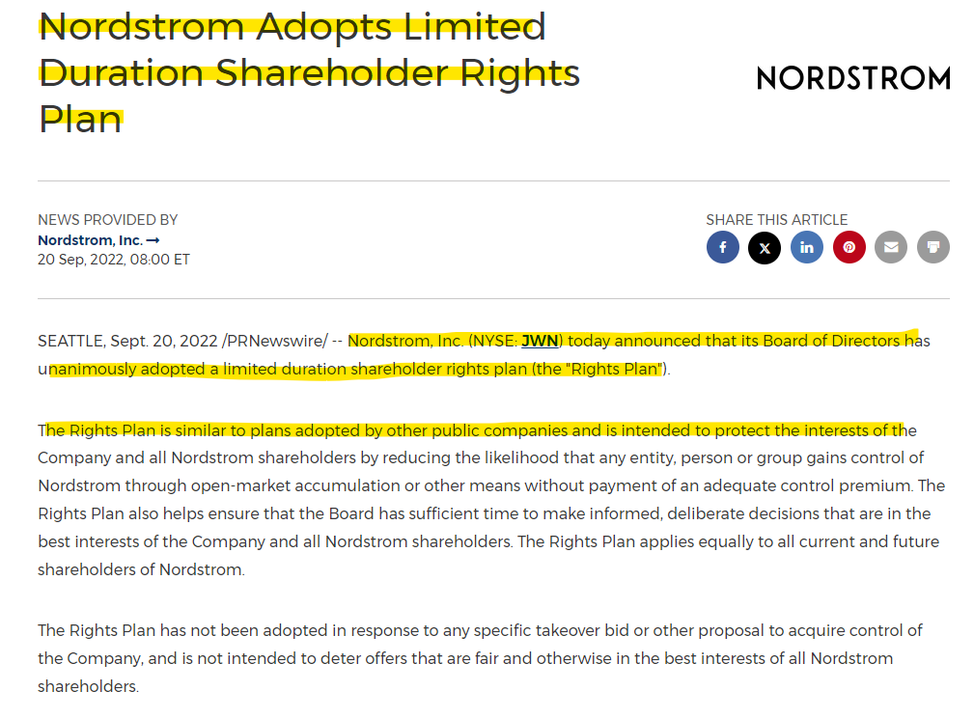

Comment-

Here, the company "Nordstrom" is announcing that they have adopted a right offering. Hence, we can tag this event under the "rights issue" category.

**Subcategory 14**

## 6.14 Ticker Symbol Update

Definition-

Involves changes in the stock ticker symbol, impacting the company's identity in financial markets. Ticker symbol updates may occur due to rebranding, mergers, or other corporate identity changes.

Example-1

CID-

Company Name-

Link-

[Radius Recycling Announces Ticker Symbol Change | Business Wire](https://www.businesswire.com/news/home/20230830455672/en/Radius-Recycling-Announces-Ticker-Symbol-Change/)

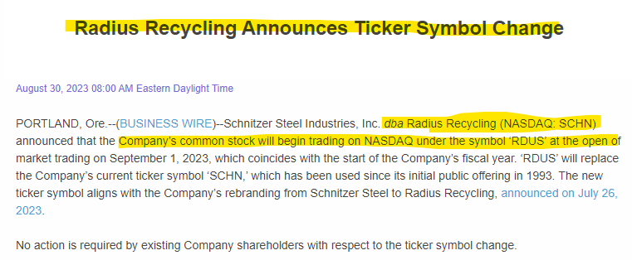

Comment-

Here the company is filing the press release to notify that they have change their ticker symbol. Hence, we can categorize this evets as Ticker symbol change.

Example-2

CID- 0C00000BO4

Company Name- Wiley

Link-

[Wiley Announces NYSE Ticker Symbol Change to WLY and WLYB | Business Wire](https://www.businesswire.com/news/home/20220315005810/en/Wiley-Announces-NYSE-Ticker-Symbol-Change-to-WLY-and-WLYB)

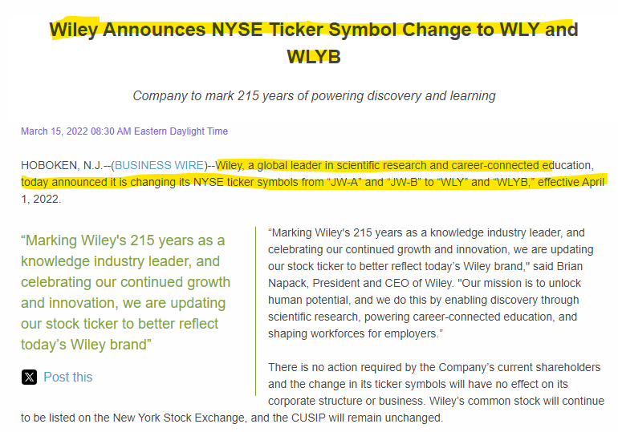

Here the company is filing the press release to notify that they have change their ticker symbol. Hence, we can categorize these evets as Ticker symbol change.

# 7 Strategic Collaborations Bulletin

Strategic collaborations refer to partnerships or alliances with other companies or organizations with the aim of achieving mutual objectives. This includes details on the nature of the collaboration, its objectives, and potential benefits for the involved parties.

Below are the examples of category of Strategic collaboration bulletin.

Example-1

CID- 0C0000BIPX

Company Name- Elastic N.V

Link-

[Elastic - Elastic Signs Strategic Collaboration Agreement with AWS to Accelerate Generative AI Solutions](https://ir.elastic.co/news/news-details/2023/Elastic-Signs-Strategic-Collaboration-Agreement-with-AWS-to-Accelerate-Generative-AI-Solutions/default.aspx)

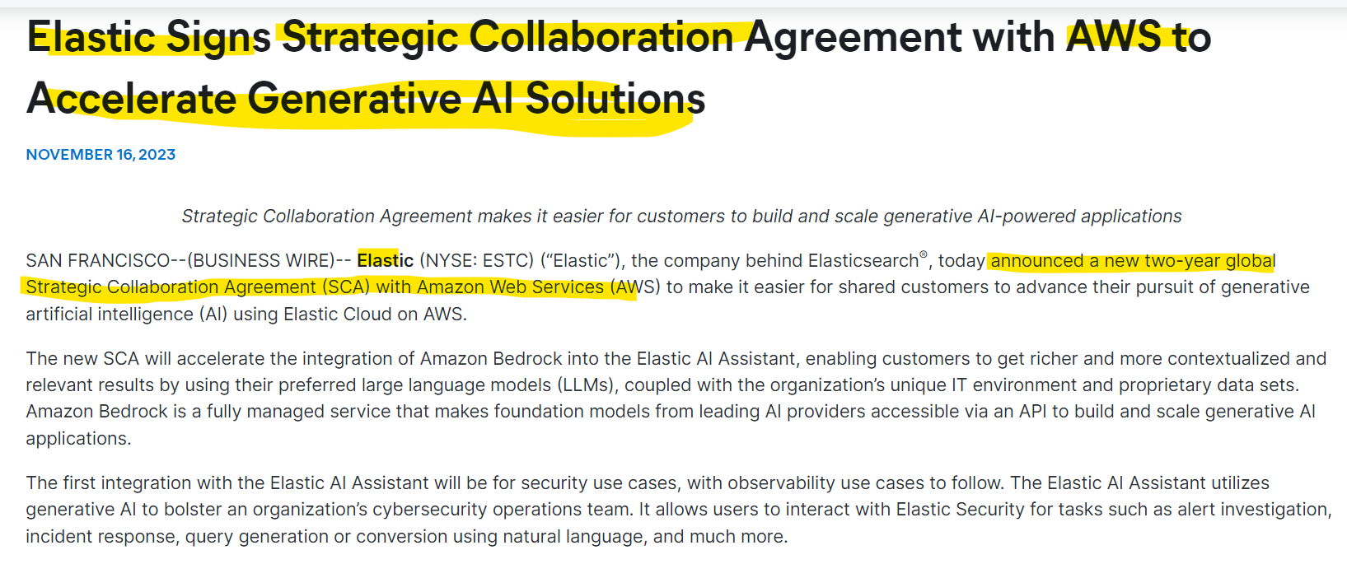

Comment-

Here the company Elastic enter to strategic collaboration with AWS to make it easier for shared customer to advance their pursuit of AI. Hence, We can categories this event as Strategic collaboration bulletin.

Example-2

CID- 0C0000BIPX

Company Name- Elastic N.V

Link-

[RingCentral - RingCentral Announces Strategic Collaboration Agreement with AWS to Help Organizations Transform their Employee and Customer Communications](https://ir.ringcentral.com/news/press-release-details/2023/RingCentral-Announces-Strategic-Collaboration-Agreement-with-AWS-to-Help-Organizations-Transform-their-Employee-and-Customer-Communications/default.aspx)

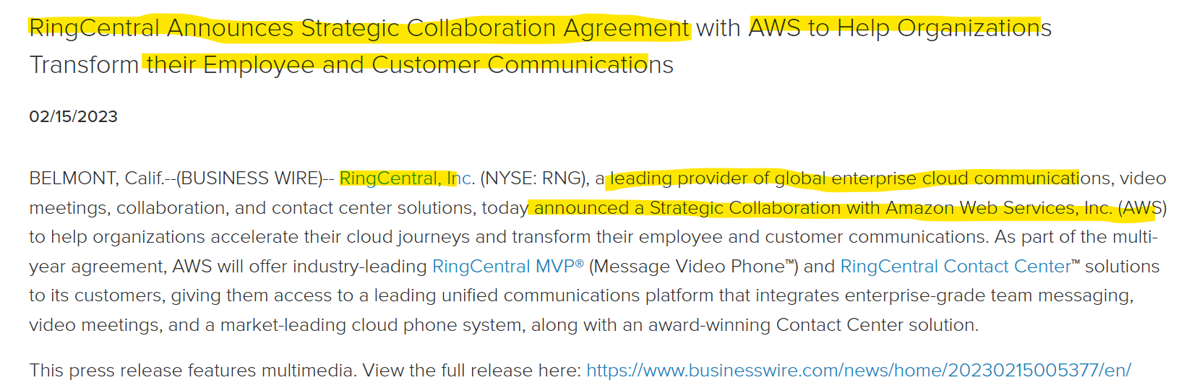

Comment-

Here the company RingCentral announces strategic collaboration with AWS. Hence, We can categories this event as Strategic collaboration bulletin.

# 8 Significant Assets Transactions

Strategic assets transaction generally refers to transactions involving a company's critical assets that can have a significant impact on its financial well-being or future operations. These investments are typically made in companies or assets that are complementary to the investor's existing business interests.

Below are the sub-categories of Significant Assets Transactions

-

1. Strategic Capital Investments
2. Disposition of Assets

Below are the examples of sub-categories within the Main category of Significant Assets Transactions -

**Subcategory 1**

## 8.1 Strategic Capital Investments

Definition-

A strategic capital investment refers to allocating a company's funds into projects or assets that aim to achieve specific business objectives. These investments may include acquisitions of key infrastructure, technology, or other assets to enhance the company's competitive position.

Example-1

CID- 0C000009AX

Company Name- Air Products and Chemicals, Inc.

Link-

<https://www.businesswire.com/news/home/20240123396615/en/SER-Capital-Partners-Secures-Strategic-Investment-from-Capricorn-Investment-Group>

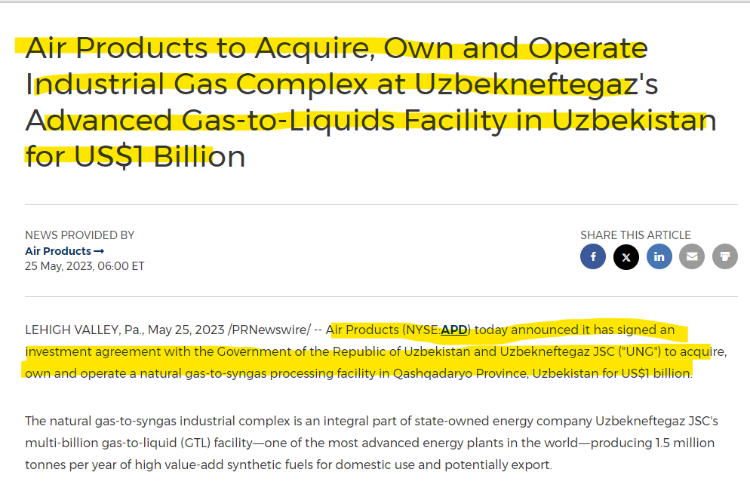

Comment-

Here the company Air product and chemical has acquired Industrial gas complex to operate a natural gas processing facility for US$ 1 billion. Hence, we can categories this evet as Strategic capital investments.

Example-2

CID- 0C00000BX6

Company Name- Nucor Corporation

Link-

[Nucor and Helion to Develop Historic 500 MW Fusion Power Plant (prnewswire.com)](https://www.prnewswire.com/news-releases/nucor-and-helion-to-develop-historic-500-mw-fusion-power-plant-301940341.html)

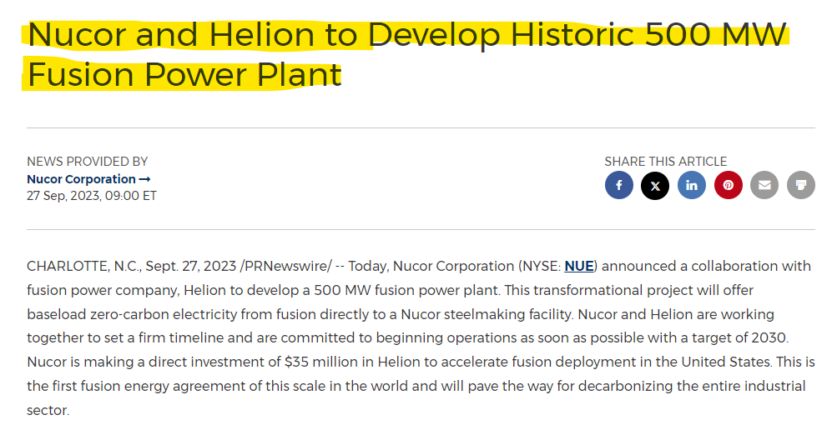

Comment-

Nucor Corp's collaboration with Helion to develop a fusion power plant can be classified as a strategic capital investment, as it represents a significant investment in an asset that will be crucial for the company's future. Hence, we can categories this evet as Strategic capital investments.

**Subcategory 2**

## 8.2 Disposition of Assets

Definition-

Involves the sale or divestiture of significant assets, potentially as part of strategic realignment, portfolio adjustment, or capital restructuring. Asset dispositions may be undertaken to focus on core operations or raise funds for specific initiatives.

Example-1

CID- 0C00000KUD

Company Name- Perpetual Energy In

Link-

[PERPETUAL ENERGY INC. ANNOUNCES ASSET DISPOSITION AND UPDATED 2023 GUIDANCE (newswire.ca)](https://www.newswire.ca/news-releases/perpetual-energy-inc-announces-asset-disposition-and-updated-2023-guidance-895042168.html)

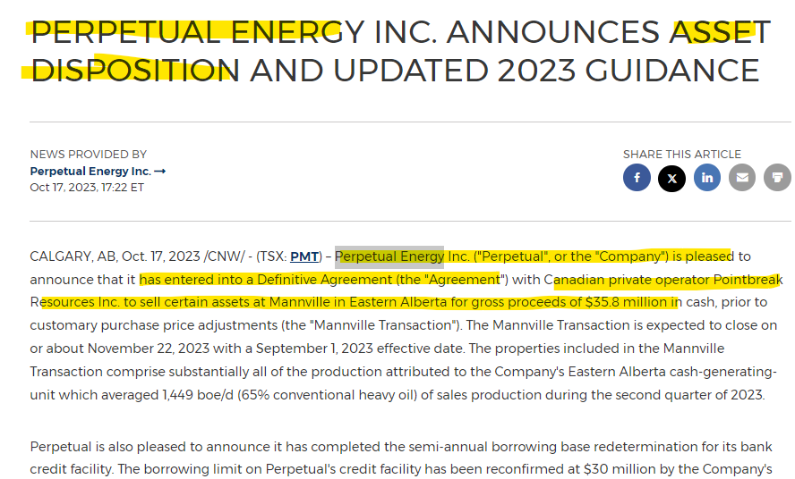

Comment-

Here the company Perpetual Energy Inc announced that they entered into the agreement with another company to sell certain of assets. Therefore, we can categorize this event as Disposition of asset.

Example-2

CID- 0C0000BUPD

Company Name- American Strategic Investment Co

Link-

<https://ir.americanstrategicinvestment.com/news/news-details/2023/American-Strategic-Investment-Co.-Announces-Disposition-of-the-Hit-Factory/default.aspx>

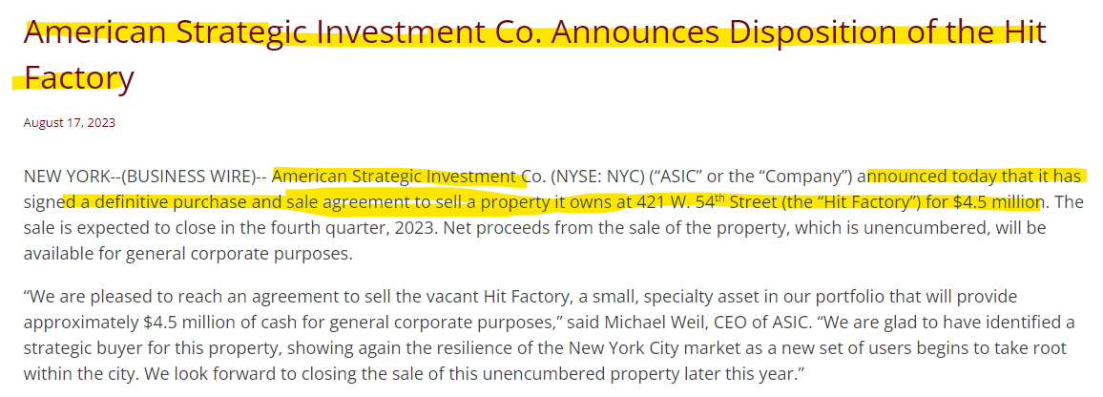

Comment-

Here the company American strategic investment co announced that they entered into the agreement to sell a property. Therefore, we can categorize this event as Disposition of asset.

**Main category-**

# junk9 Legal and Regulatory Updates

This category involves notifications about changes in legal and regulatory matters that may impact the company's operations. It includes updates on regulatory compliance, legal actions, and changes in relevant legislation.

Below are the examples of category of Legal and Regulatory updates.

Example-1

Company Name- Florida power and Light company

Link-

[State regulators approve FPL rate decrease in May (prnewswire.com)](https://www.prnewswire.com/news-releases/state-regulators-approve-fpl-rate-decrease-in-may-301789894.html)

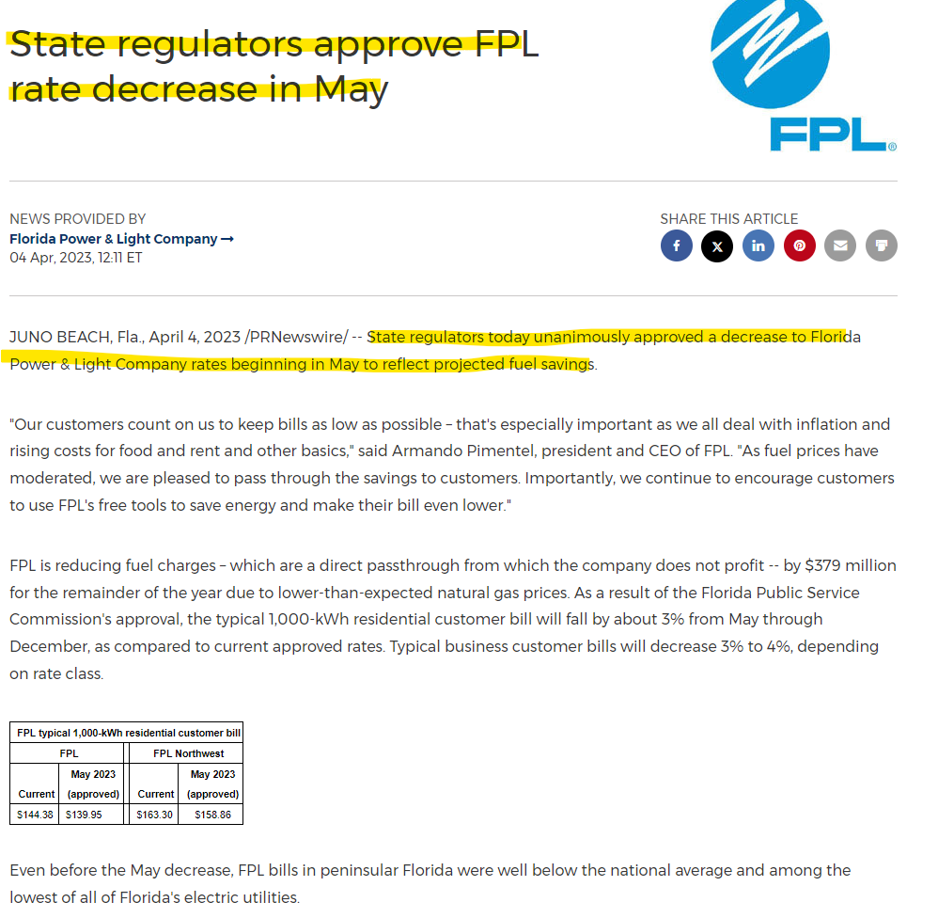

Comment-

Here the news contains the information about state regulator approving the FPL rate decrease to Florida power and light company in May which will benefit to the company by fuel saving. Hence, we can categories this event as Legal and regulatory matters.

**Main category-**

# 10 Product/Service Releases and Updates

Encompasses announcements and updates regarding new product or service launches, enhancements, or modifications. This includes information on features, benefits, and market positioning, helping stakeholders understand the company's innovation and market strategy. Product and service releases highlight the company's commitment to meeting customer needs and staying competitive.

Below are the examples of category of Product/Service Release and Updates.

Example-1

CID- 0C000008L4

Company Name- RadNet

Link-

[RadNet Launches EBCD in New York and New Jersey](https://www.radnet.com/about-radnet/news/ebcd-new-york-new-jersey)

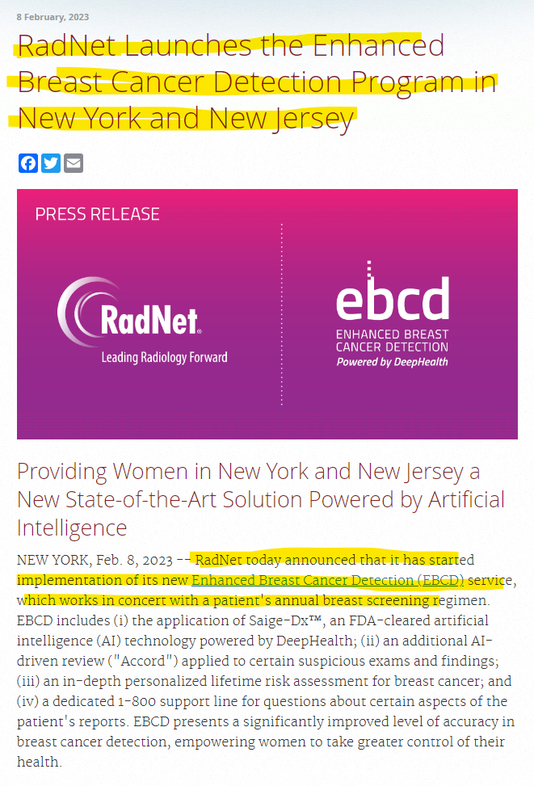

Comment-

Here the company notifying that they have launches a new breast cancer detection program via this press release. Hence, we can categorize this event under Product/Service releases and updates.

# 11 Investor Engagement

This category includes communication and relationship building between companies and its investors. It's a two-way street where the company informs investors about its activities, performance, and future plans, while also gaining valuable insights from investors' questions and feedback.

Below are the sub-categories of Investor Engagement-

1. Earnings Conference
2. Conferences & Summits
3. Annual General Meeting
4. Extra-ordinary General Meeting
5. Fireside chats
6. Analyst/Investor Day
7. Roadshow

Below are the examples of sub-categories within the Main category of Investor Engagement-

**Subcategory 1**

## 11.1 Earnings Conference

Definition-

A periodic call or webcast where a company's management team discusses its financial results, future outlook, and answers questions from analysts and investors. Earnings conferences allow for direct communication between company leadership and the investor community.

Example-1

CID- 0C00000BMT

Company Name- JPMorgan Chase & Co

Link-

<https://www.jpmorganchase.com/ir/news/2024/jpmc-to-host-first-quarter-2024-earnings-call>

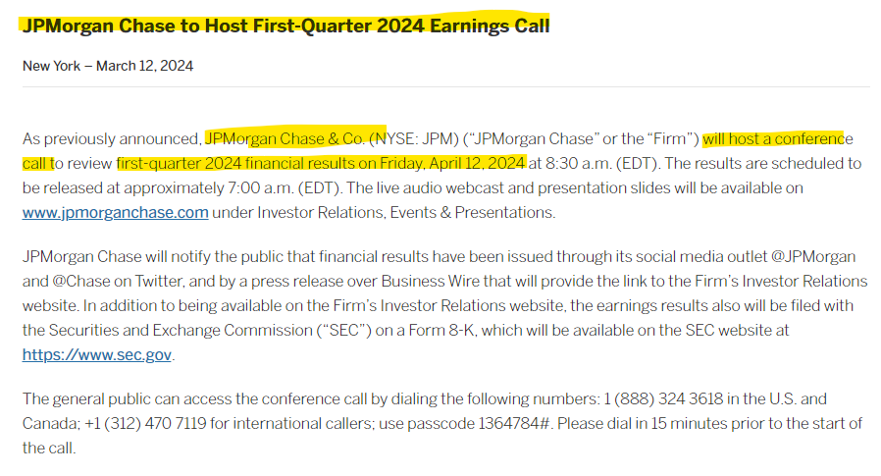

Comment-

Here the company is notifying via press release that they have host a conference call to review financial results. Hence, we can categorize this event under Earning conference.

Example-2

CID- 0C00000BX6

Company Name- Nucor Corp

Link-

[Nucor Invites You to Join Its Second Quarter of 2023 Conference Call on the Web (prnewswire.com)](https://www.prnewswire.com/news-releases/nucor-invites-you-to-join-its-second-quarter-of-2023-conference-call-on-the-web-301871519.html)

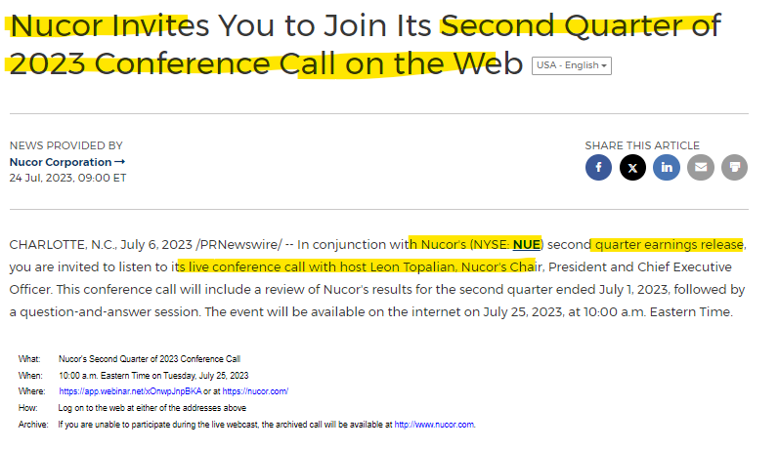

Comment-

Here the company is notifying via press release that they have host a conference call to review financial results. Hence, we can categorize this event under Earning conference.

**Subcategory 2**

## 11.2 Conferences & Summits

Definition-

Industry events where companies can present to a large audience of potential investors, analysts, and media representatives. Participation in conferences and summits is a strategic marketing and networking activity.

Example-1

CID-

Company Name- Orian SA

Link-

[Orion - Orion S.A. to Participate in Upcoming Investor Conferences (orioncarbons.com)](https://investor.orioncarbons.com/financial-press-releases/press-releases-details/2023/Orion-S.A.-to-Participate-in-Upcoming-Investor-Conferences/default.aspx)

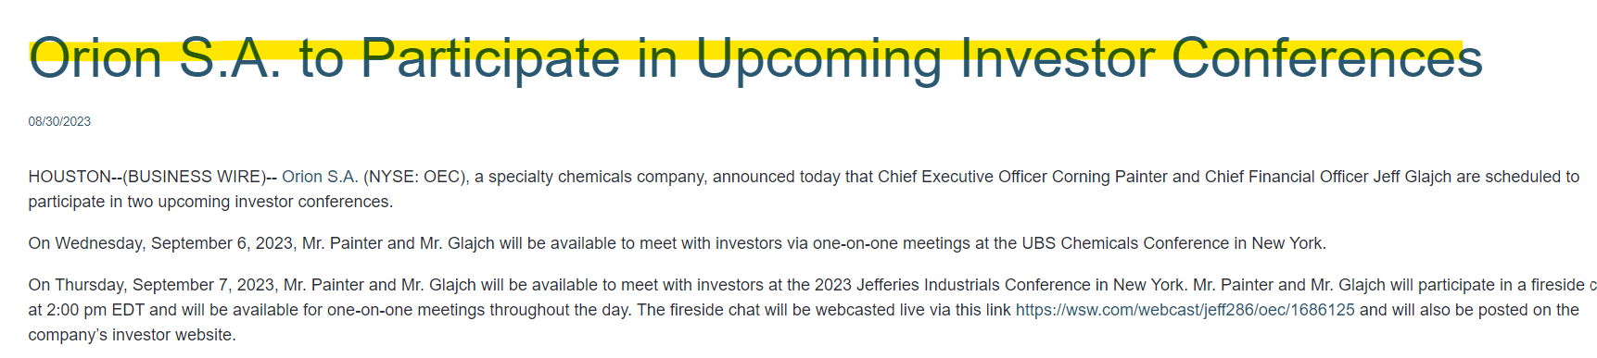

Comment-

The company is notifying via press release that **company's executives will be participating in a series of upcoming investor conferences.**Therefore, we can categorize this event as conferences and Summits.

**Subcategory 3**

## 11.3 Annual General Meeting

Definition-

A yearly meeting where a company presents its financial statements, elects directors, and votes on other proposals. All shareholders are invited to attend and participate.

Example-1

CID- 0C0000CSD4

Company Name- Lanvin Group

Link-

<https://www.prnewswire.com/news-releases/lanvin-group-holdings-limited-to-hold-annual-general-meeting-on-december-21-2023-302010038.html>

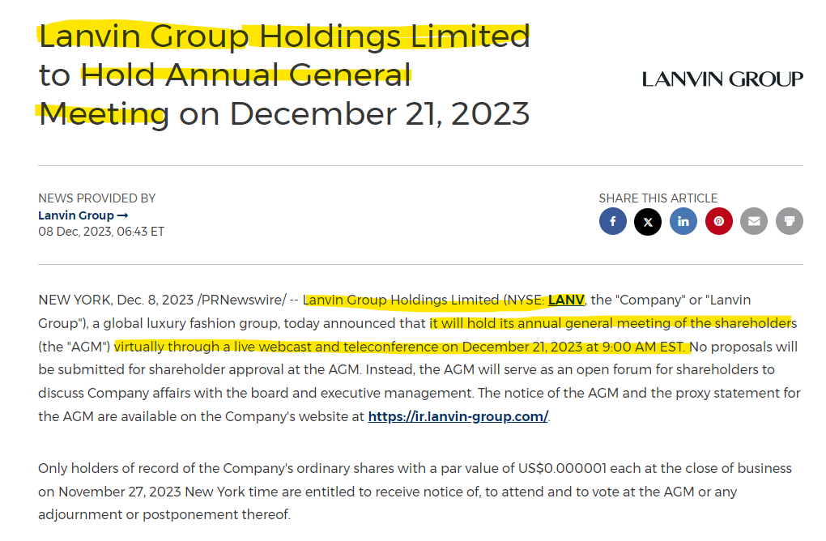

Comment-

The company has announced an Annual General Meeting (AGM) of shareholders**.** Therefore, this event falls under the category of Extra-ordinary general meeting.

Example-2

CID-

Company Name- Philip Morris International Inc

Link-

[Investors Press Releases | PMI - Philip Morris International](https://www.pmi.com/investor-relations/press-releases-and-events/press-releases-overview/press-release-details/?newsId=26401)

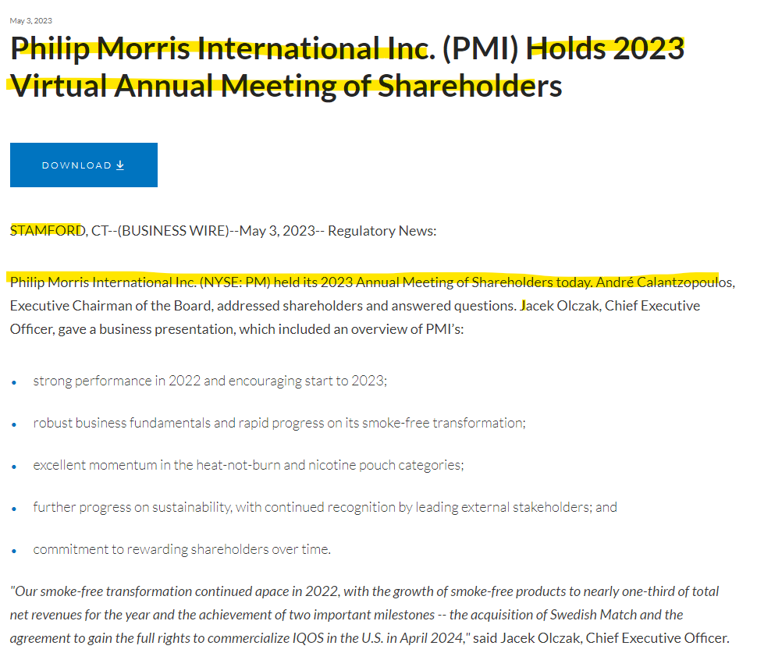

Comment-

The company has announced an Annual General Meeting (AGM) of shareholders**.** Therefore, this event falls under the category of Extra-ordinary general meeting.

**Subcategory 4**

## 11.4 Extra-ordinary General Meeting

Definition-

Extra-ordinary General meetings are specifically called to address urgent or significant issues that fall outside the purview of AGMs and require shareholder approval such as a merger or acquisition.

Example-1

CID- 0C00009VY7

Company Name- QIWI plc

Link-

<https://qiwi.global/news-and-events/press-releases/4108580/>

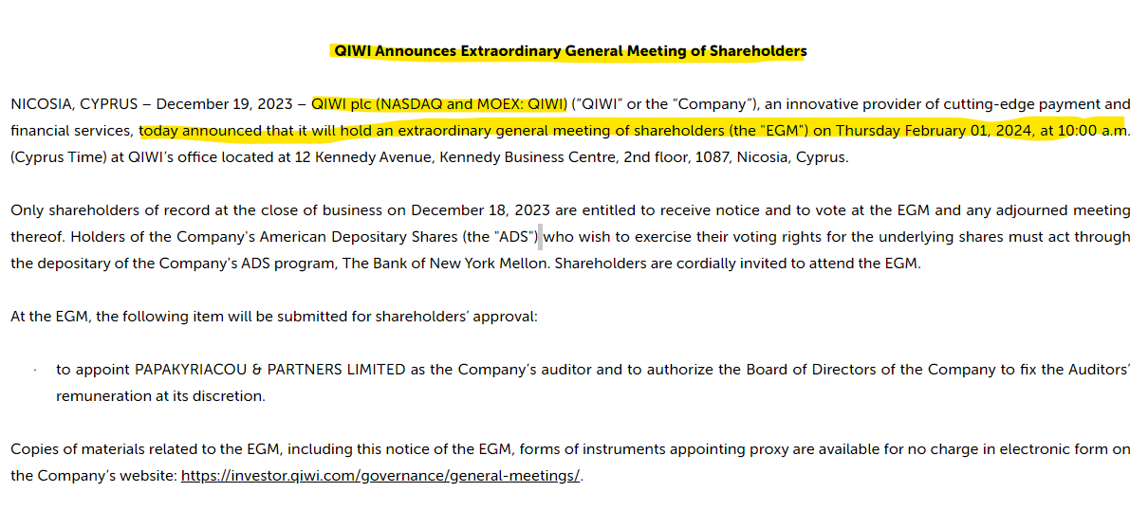

Comment-

The company has announced an Extraordinary General Meeting (EGM) of shareholders**.** Therefore, this event falls under the category of Extra-ordinary general meeting.

Example-2

CID- 0C00000ASP

Company Name- CRH plc

Link-

[a8362y (sec.gov)](https://www.sec.gov/Archives/edgar/data/849395/000165495423006035/a8362y.htm)

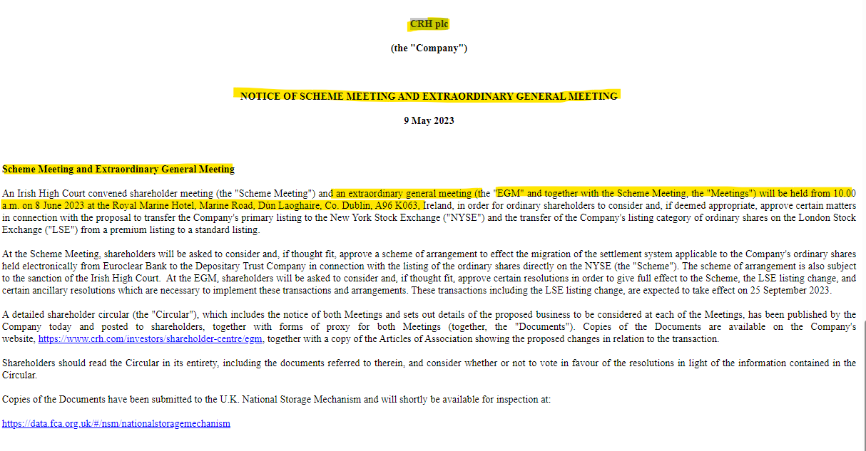

Comment-

The company has announced an Extraordinary General Meeting (EGM) of shareholders**.** Therefore, this event falls under the category of Extra-ordinary general meeting.

**Subcategory 5**

## 11.5 Fireside chats

Definition-

Informal conversations between a company executive and an investor or analyst, providing insights into the company's strategy, vision, and current market conditions.

Example-1

CID- 0C000008AM

Company Name- Soluna Holdings

Link-

<https://www.businesswire.com/news/home/20240115900011/en/Soluna-to-Participate-in-Water-Tower-Research-Fireside-Chat-Series>

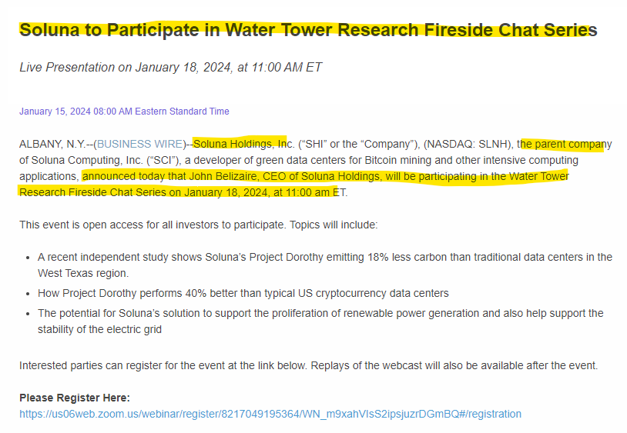

Comment-

The company announced its participation in the Water Tower Research Fireside Chats series via press release. Therefore, this event falls under the category of Fireside chats.

Example-2

CID- 0C00000B7U

Company Name- Hasbro

Link-

[Hasbro to Webcast Live Fireside Chat with UBS | Hasbro, Inc.](https://investor.hasbro.com/news-releases/news-release-details/hasbro-webcast-live-fireside-chat-ubs)

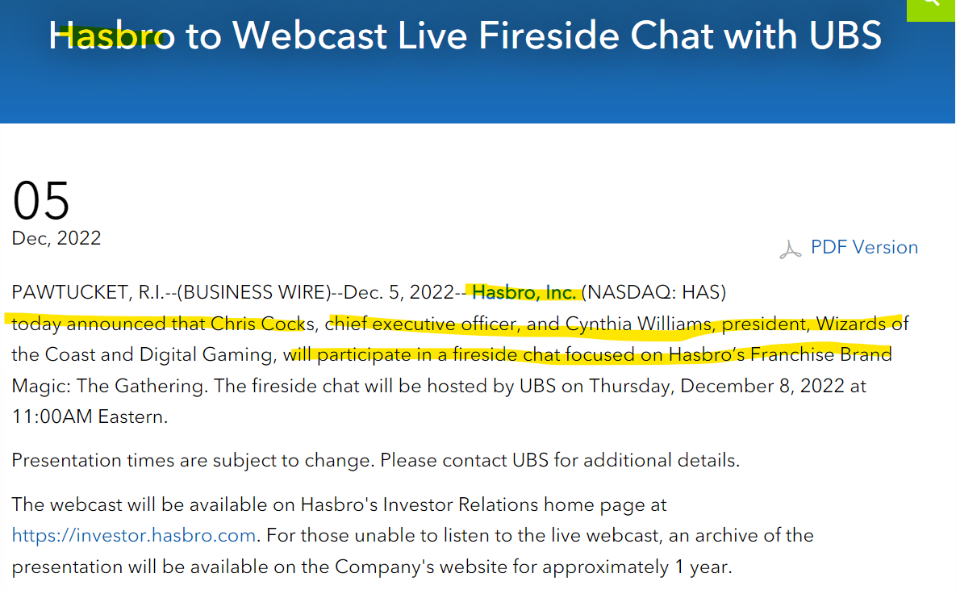

Comment-

**Hasbro is** announcing **that its executives will participate in a fireside chat focused on the company's franchise brand, Magic: The Gathering.** Therefore, this event falls under the category of Fireside chats.

**Subcategory 6**

## 11.6 Analyst/Investor Day

Definition-

**An Analyst/Investor Day is an event held by a company specifically for financial analysts and investors. It's basically a day-long presentation by the company to directly communicate their plans, strategies, and future outlook to those who influence their stock price and access to capital.**

Example-1

CID- 0C0000C2QH

Company Name- Leonardo DRS

Link-

<https://www.businesswire.com/news/home/20240314330123/en/Leonardo-DRS-to-Host-Investor-Day>

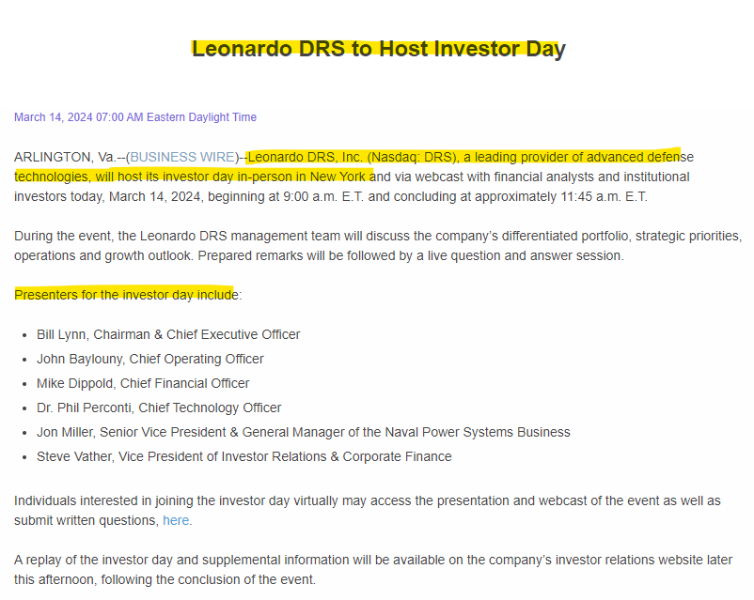

Comment-

The company notifying that they have hosted investor day via this press release hence we can categorize this event as Analyst/investor Day.

Example-2

CID- 0C0000CA2M

Company Name- Aurora Innovation

Link-

<https://ir.aurora.tech/news-events/press-releases/detail/91/aurora-to-host-analyst-investor-day>

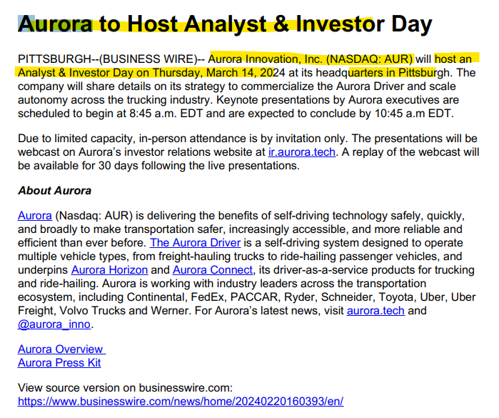

Comment-

The company notifying that they have hosted analyst and investor day via this press release hence we can categorize this event as Analyst/investor Day.

**Subcategory 7**

## 11.7 Roadshow

Definition-

A day-long event where a company presents detailed information about its business strategy, growth plans, and financial performance to analysts and investors.

This involves meetings with institutional investors, analysts, and other stakeholders in different locations.

Example-1

CID- 0C0000BZPD

Company Name- DoorDash Inc

Link-

<https://ir.doordash.com/news/news-details/2020/DoorDash-Announces-Launch-of-Initial-Public-Offering/default.aspx>

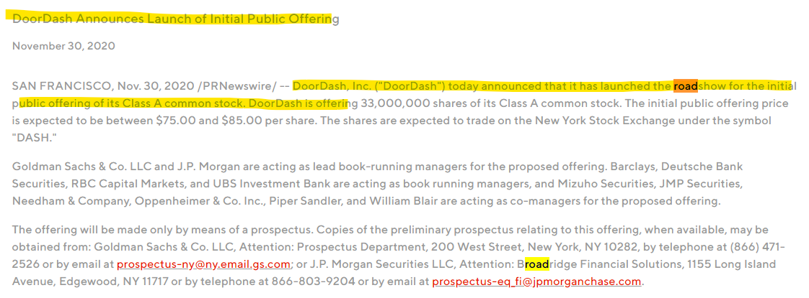

Comment-

Here the company DoorDash is announcing that they have launched the roadshow for Initial public offering for their common stocks. Hence, we can categories this event as Roadshow.

# 12 Operational Updates

Operational updates are targeted communications that inform stakeholders about various aspects affecting a company's ongoing operations. By providing details within these subcategories, operational updates give stakeholders a comprehensive picture of how the company's day-to-day operations are evolving.

Below are the sub-categories of operational updates-

1. Suspension of business/Facility
2. New Commercial Facility
3. Critical Incident Updates
4. Management Guidance
5. Workforce Transition Updates
6. Financial Segment Restructuring
7. Sales and Production Figures
8. Orders and Contracts
9. Regulatory Approvals and Compliance
10. Pricing Updates
11. Business Updates

Below are the examples of sub-categories within the Main category of operational updates-

**Subcategory 1**

## 12.1 Suspension of business/Facility

Definition-

Notification of cessation of business activities or halting of business operations, often due to unforeseen circumstances or strategic reasons. Suspensions of business may impact financial performance and customer relationships.

Example-1

Company Name-Mastercard

Link-

[Mastercard Incorporated - Mastercard Statement on Suspension of Russian Operations](https://investor.mastercard.com/investor-news/investor-news-details/2022/Mastercard-Statement-on-Suspension-of-Russian-Operations/default.aspx)

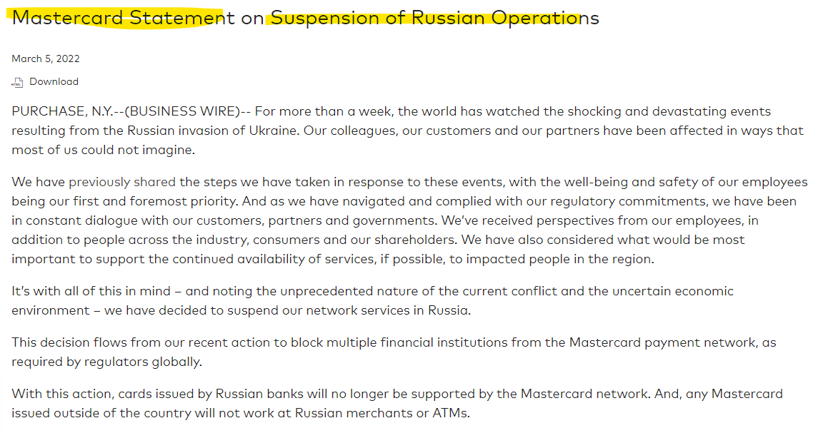

Comment-

Here the company is announcing that they have suspended their business activity from Russia. Hence, we need to categories this event as suspension of business/Facility.

**Subcategory 2**

## 12.2 New Commercial Facility

Definition-

Encompasses the opening or establishment of new commercial facilities, indicating potential business expansion or relocation.

Example-1

Company Name- Raytheon

Link-

[Raytheon to open new facility at SkySong, The Arizona State University Scottsdale Innovation Center (prnewswire.com)](https://www.prnewswire.com/news-releases/raytheon-to-open-new-facility-at-skysong-the-arizona-state-university-scottsdale-innovation-center-301878738.html)

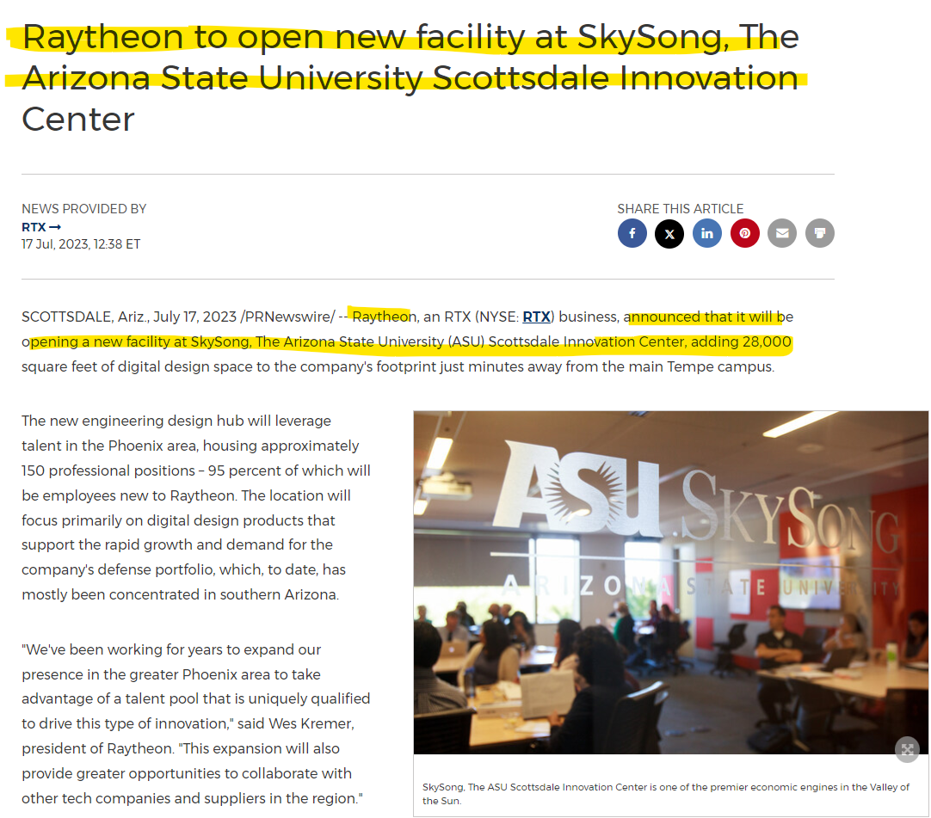

Comment-

Here in the above snip the company is notifying that they have opened new facility at Skysong. Therefore, we need to categories this event as new commercial facility.

Example-2

Company Name- Americold

Link-

[Americold Announces Plans for First Cold Storage Facility on CPKC Rail Network in Missouri - Americold](https://ir.americold.com/press-releases/news-details/2024/Americold-Announces-Plans-for-First-Cold-Storage-Facility-on-CPKC-Rail-Network-in-Missouri/default.aspx)

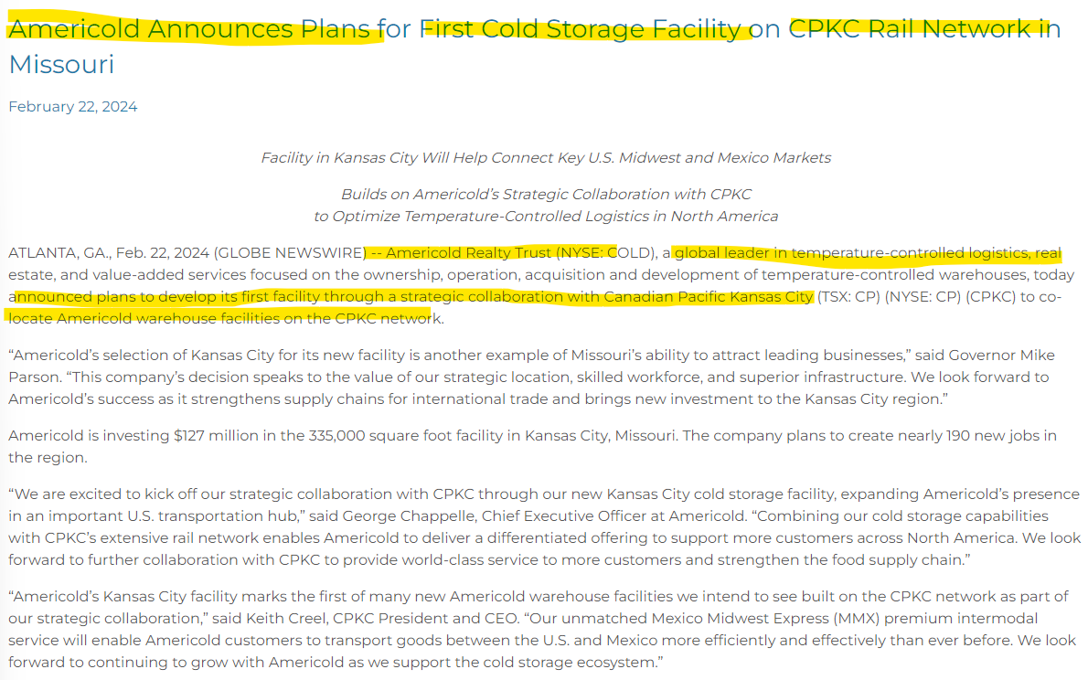

Comment-

Here in the company Americold is notifying that they have plan to open first cold storage on CPKC rail network in Missouri. Therefore, we can categories this event as new commercial facility.

**Subcategory 3**

## 12.3 Critical incident updates

Definition-

This section would provide information on critical events that may impact operations, such as natural disasters, security breaches, or major equipment failures.

Example-1

Company Name- IBM

Link-

[IBM Addresses Data Incident for Janssen CarePath Database (prnewswire.com)](https://www.prnewswire.com/news-releases/ibm-addresses-data-incident-for-janssen-carepath-database-301919907.html)

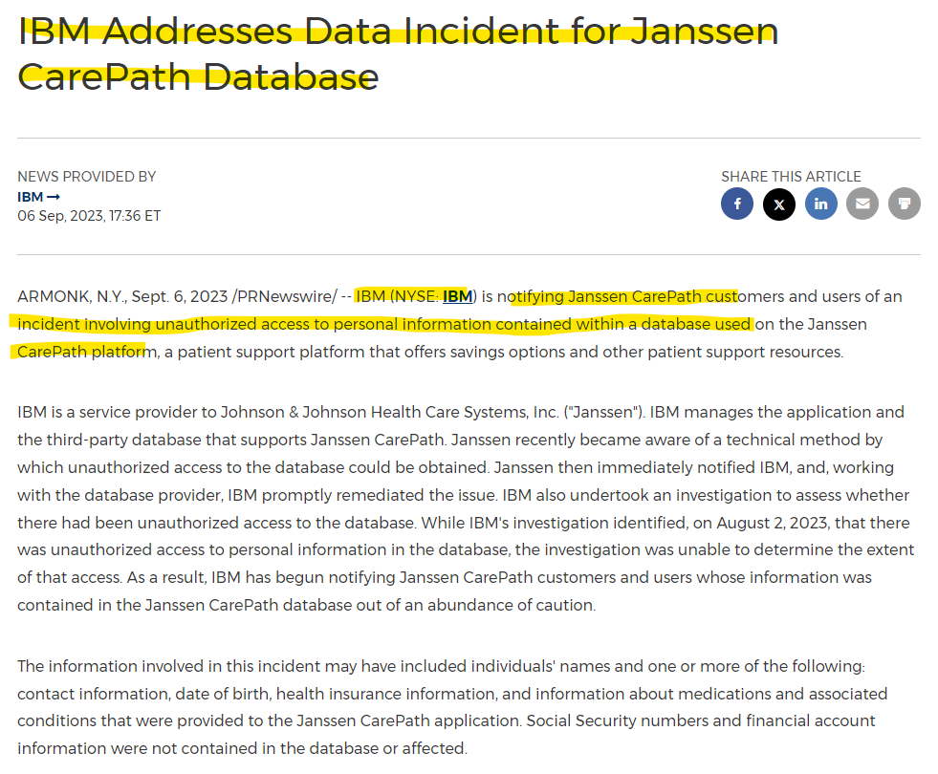

Comment-

Here the company is notifying via press release the data incident for Janssen carepatah database. Hence this evet is falling under the category of Critical incident updates.

Example-2

Company Name- T-Mobile

Link-

[XBRL Viewer (sec.gov)](https://www.sec.gov/ix?doc=/Archives/edgar/data/0001283699/000119312523010949/d641142d8k.htm)

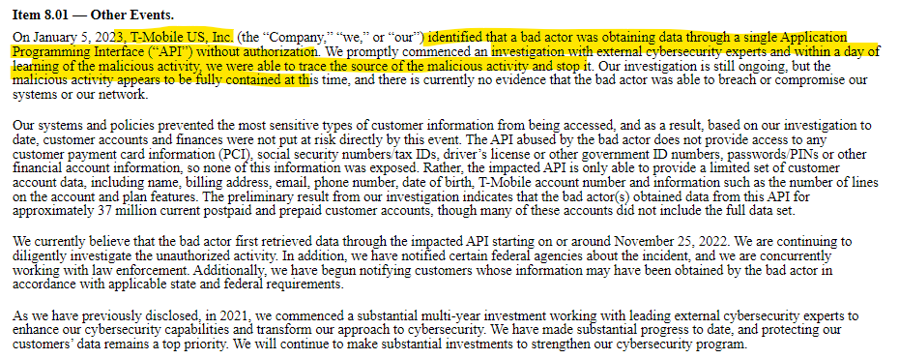

Comment-

Here the company is notifying that someone hacked into T-Mobile's system and got some customer data without permission. Hence, we need to categorize this event as Critical incident updates.

**Subcategory 4**

## 12.4 Management Guidance

0

Definition-

Directives, advice, or guidance provided by the management to stakeholders regarding the company's future strategies, goals, or anticipated challenges. This section would communicate important directives or changes in policies from company leadership.

Example-1

Company Name- Nucor

Link-

[Nucor Announces Guidance for the Third Quarter of 2023 Earnings (prnewswire.com)](https://www.prnewswire.com/news-releases/nucor-announces-guidance-for-the-third-quarter-of-2023-earnings-301928438.html)

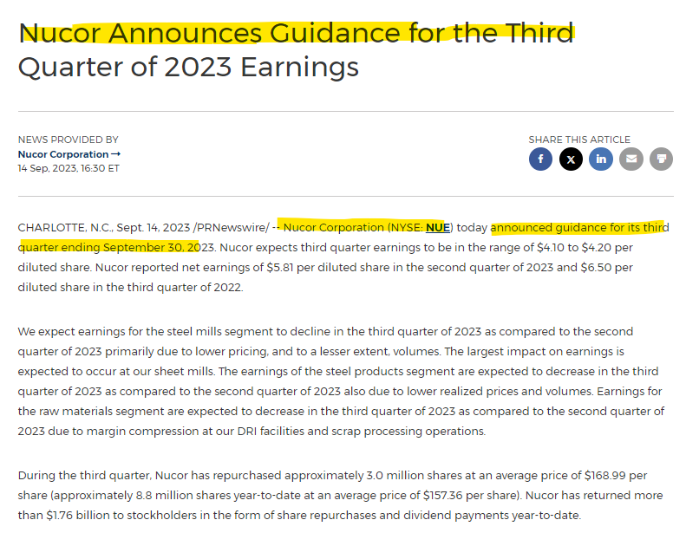

Comment-

Here the company is announcing via press release the management guidance for the third quarter of 2023. Hence, we need to categorize this event management guidance.

Example- 2

Company Name- Torrid Holdings

Link-

[Torrid Reports Fourth Quarter and Fiscal 2023 Results and Initiates Fiscal 2024 Guidance | Business Wire](https://www.businesswire.com/news/home/20240328211466/en/Torrid-Reports-Fourth-Quarter-and-Fiscal-2023-Results-and-Initiates-Fiscal-2024-Guidance)

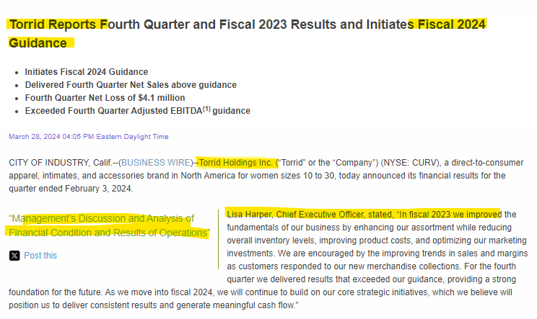

Comment-

Here, the company is announcing via press release the management's guidance for fiscal year 2024. Hence, we can categorize this event as guidance.

**Subcategory 5**

## 12.5 Workforce Transition Updates

Definition-

This subcategory would provide information about workforce changes, such as layoffs, hiring freezes, or restructuring.

Example-1

Company Name- FedEx

Link-

[Organizational Changes (fedex.com)](https://newsroom.fedex.com/newsroom/global-english/organizational-changes)

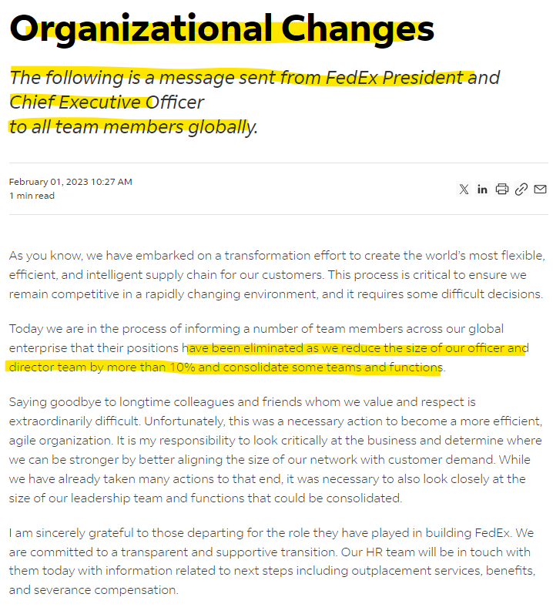

Comment-

Here the company FedEx notifying via press release about reducing the size of the workforce. Hence, we can categorize this event as Workforce Transition Updates.

Example-2

Company Name- Meta

Link-

<https://about.fb.com/news/2022/11/mark-zuckerberg-layoff-message-to-employees/>

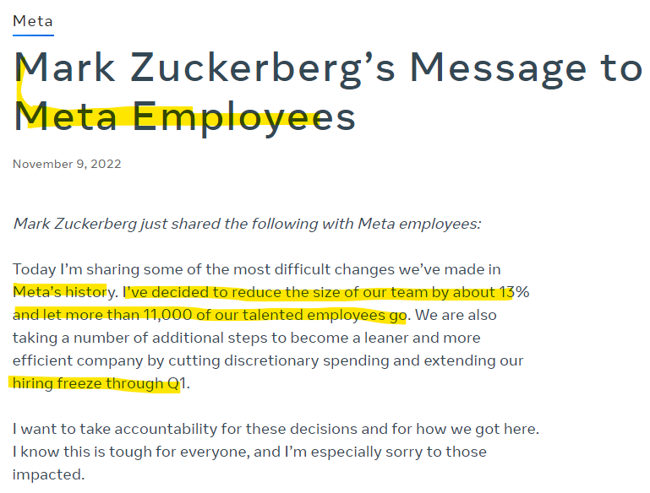

Comment-

Here, the company Meta announced a workforce reduction and hiring freeze through Q1 via press release. Hence, we can categorize this event as Workforce Management Updates.

**Subcategory 6**

## 12.6 Financial Segment Restructuring

Definition-

Announcements regarding changes in the financial structure of the organization, which involve reorganizing business segments for improved efficiency.

Example-1

Company Name- AptarGroup

Link-

[Aptar Announces the Realignment of Two of its Business Reporting Segments | Aptar](https://investors.aptar.com/news/news-details/2022/Aptar-Announces-the-Realignment-of-Two-of-its-Business-Reporting-Segments/default.aspx)

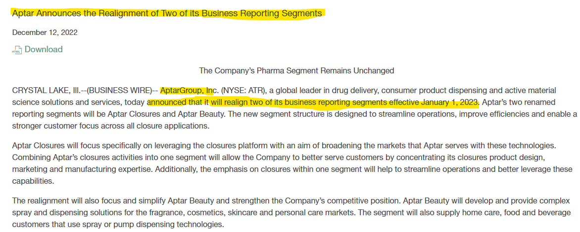

Comment-

In the above snippet, we can see that the company is announcing they have realigned two of their business segments from January 1, 2023. Therefore, we can categorize this event as Business Segment Realignment.

Example-2

Company Name- HCA Healthcare

Link-

[Inline Viewer: HCA Healthcare, Inc. 8-K 2023-05-26 (sec.gov)](https://www.sec.gov/ix?doc=/Archives/edgar/data/0000860730/000119312523155487/d495615d8k.htm)

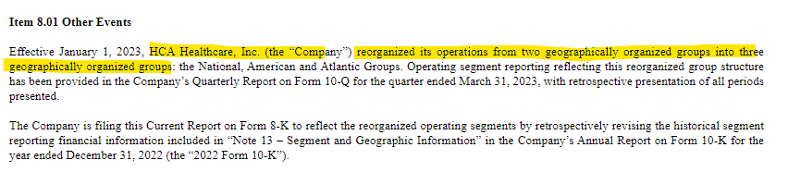

Comment-

Here the company HCA Healthcare restructured its operations from two to three geographic groups (National, American, and Atlantic) effective January 1, 2023. Hence, we can categorize this event as Financial Segment Restructuring.

**Subcategory 7**

## 12.7 Sales and Production Figures

Definition-

Reports on the company's sales and production performance, providing insights into its market presence and operational efficiency.

Example-1

Company Name- Rivian Automotive

Link-

<https://www.businesswire.com/news/home/20240402535953/en/Rivian-Releases-Q1-Production-Figures-and-Sets-Date-for-First-Quarter-2024-Results>

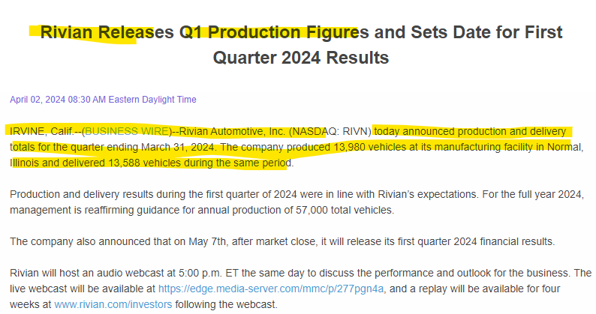

Comment-

Here in the above press release company is publishing their production figures for the quarter ending March 2024. Therefore, we can categorize this news as Sales and production figures.

Example-2

Company Name- Fisker

Link-

<https://www.businesswire.com/news/home/20230707642038/en/Fisker-Reports-Q2-2023-Production-Figures-and-Announces-Second-Quarter-2023-Results-Date>

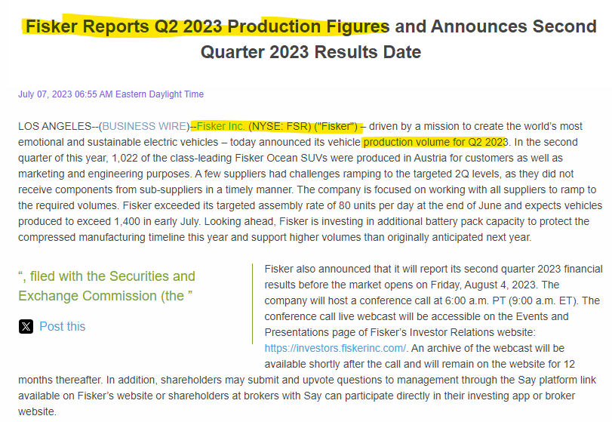

Comment-

Here in the above press release Fisker is publishing their production Volume for the Q2 2023. Therefore, we can categorize this news as Sales and production figures.

**Subcategory 8**

## 12.8 Orders and contracts

Definition-

Information about new orders secured or contracts signed, reflecting the organization's success in business development and client relations.

Example-1

Company Name- CACI International Inc

Link-

<https://www.businesswire.com/news/home/20240320472310/en/CACI-Secures-239-Million-Task-Order-for-U.S.-Army-Unified-Network-Modernization>

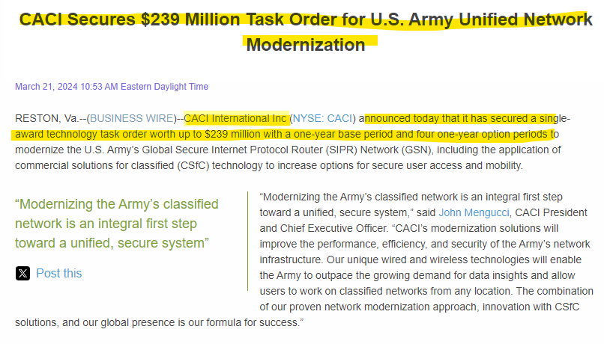

Comment-

Here the company is announcing that they have secured a task order for US Army with one year base period. Therefore, we can categorize this news as Orders and contract.

Example-2

Company Name- NV5 Global Inc

Link-

[NV5, Inc - NV5 Awarded $25 Million in Resident Inspection Services by the New York City Department of Design and Construction](https://ir.nv5.com/news-events/news-releases/news-details/2023/NV5-Awarded-25-Million-in-Resident-Inspection-Services-by-the-New-York-City-Department-of-Design-and-Construction/default.aspx)

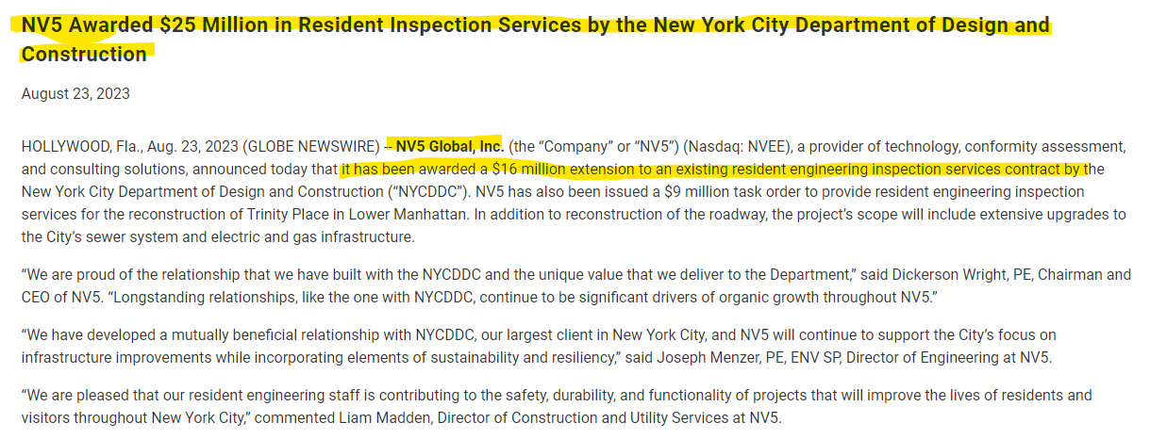

Comment-

Here the company announcing that they have receive a task order to provide resident inspection services by NY city department. Therefore, we can categorize this news as orders and contract.

**Subcategory 9**

## 12.9 Regulatory Approvals and Compliance

Definition-

Updates on regulatory approvals received or compliance measures taken, ensuring adherence to legal and industry standards.

Example-1

Company Name- Pfizer

Link-

<https://www.businesswire.com/news/home/20231212889916/en/Pfizer-Receives-All-Required-Regulatory-Approvals-to-Complete-the-Acquisition-of-Seagen>

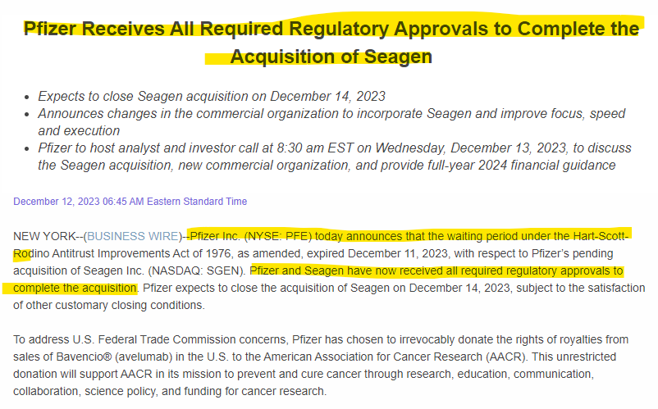

Comment-

Here, Pfizer has announced that they have received all the regulatory approvals to complete the acquisition. Hence, we can categorize this event under 'Regulatory Approvals and Compliance' as well as under 'Mergers and Acquisitions.

Example-2

Company Name- Bosten Scientific Corp

Link-

<https://news.bostonscientific.com/2023-09-06-Boston-Scientific-Announces-FDA-Approval-for-the-Latest-Generation-WATCHMAN-FLX-TM-Pro-Left-Atrial-Appendage-Closure-Device>

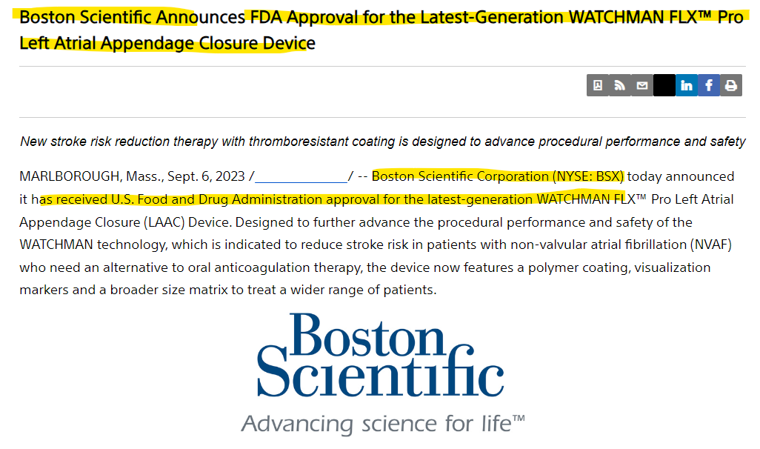

Comment-

Here the company is announcing via press release that they have received FDA approval for the latest generation watchman FLX. Hence, we can categories this event as ‘Regulatory Approvals and Compliance’.

**Subcategory 10**

## 12.10

## Updates

Definition-

Notifications regarding changes in product or service pricing, which can impact both customers and the company's financial performance.

Example-1

Company Name-

Link-

<https://www.ufpi.com/our-company/news-events/news/2022/12-16-22>

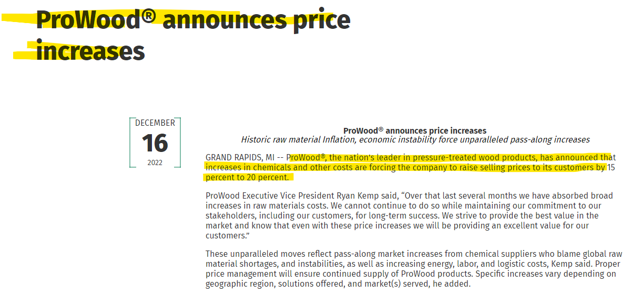

Comment-

Here the company is announcing that they have increased the selling prices of their products by 15 to 20 percent. Hence, we can categorize this event as Pricing updates.

Example-2

Company Name- Cleveland-Cliffs Inc

Link-

<https://www.businesswire.com/news/home/20230616747879/en/Cleveland-Cliffs-Announces-Price-Increase-for-Flat-Rolled-Steel-Products>

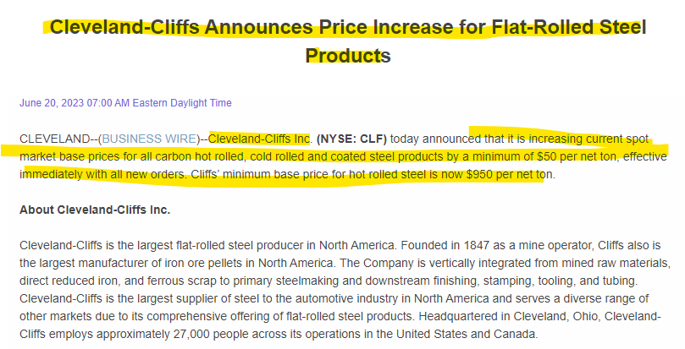

Comment-

Here the company Cleveland cliffs announced that they have increases the price for flat rolled steel products. Hence, we can categorize this event as Pricing updates.

**Subcategory 11**

## 12.11 Business updates

Definition-

All the operational updates that do not fall under the above defined categories shall fall under business updates category.

Example-1

Company Name-Accenture

Link-

[Seabridge Gold](https://www.seabridgegold.com/press-release/seabridge-gold-begins-drilling-at-the-3-aces-project)

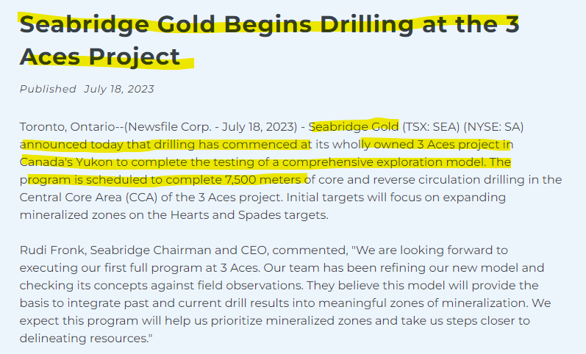

Comment-

Here, the company is announcing that they have begun drilling at the 3 Aces project. This operational update is provided by the company via a press release. As this operational update does not fall under any of the operation categories, we need to categorize this under business updates as residual.

# 13 Legal Investigations & Lawsuits

Definition-

Informs stakeholders about any legal actions initiated against or by the company, encompassing a range of legal matters such as disputes, litigation, and regulatory proceedings. This category includes official announcements detailing the nature of the legal claims, parties involved, key allegations, and potential impacts on the company's financial and operational standing.

Example-1

CID-

Company Name- Amazon

Link-

[Amazon’s Counterfeit Crimes Unit Files Lawsuits Against Bad Actors Attempting to Use Social Media to Knowingly Sell Counterfeit Luxury Items | Business Wire](https://www.businesswire.com/news/home/20230906148747/en/)

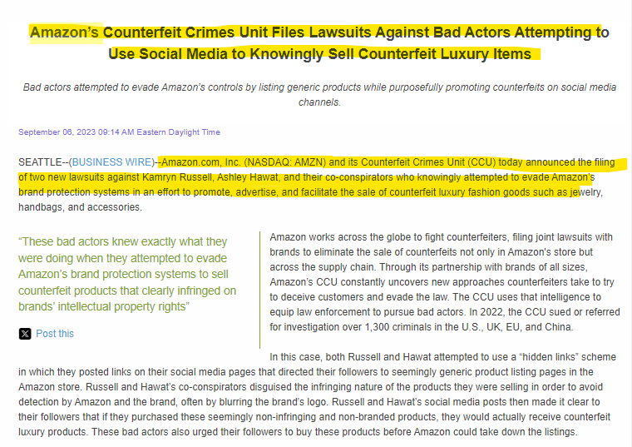

Comment-

Here the company is publishing via press release that they have filed a lawsuit against bad actors. Based on this information we can categorize this event as Legal and Regulatory updates.

Example-2

CID-

Company Name- Tesla

Link-

[Hagens Berman: Class-Action Lawsuit Says Tesla’s Automatic Software Updates Derate Batteries, Violate Computer Fraud and Abuse Act | Business Wire](https://www.businesswire.com/news/home/20230428005452/en/)

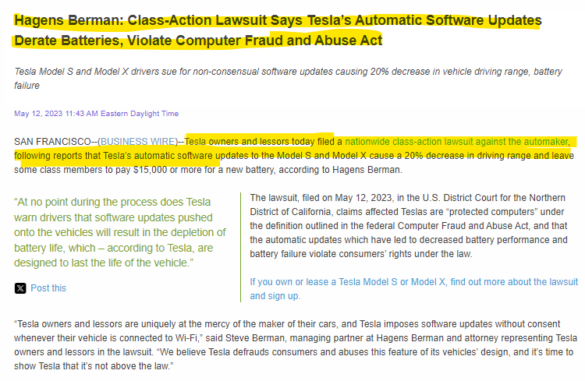

Comment-

This press release pertains to Tesla owners filing a lawsuit against the company, claiming that automatic software updates have negatively impacted their vehicles. Allegations include a potential 20% reduction in driving range and costs of up to $15,000 for a new battery. Hence, this event should be categorized as "Legal Investigations & Lawsuits."

# 14 Others

Definition-

Any news or events that do not fit into the main category or sub-category listed above should be classified under this residual category.

**Carmell Corporation Appoints New CEO Following Addition to the Russell Microcap Index**